**12.3**

**Association Rule Mining**

**Association rule mining**: given a set of transactions, finding rules that predict the co-occurrence of items in a transaction

Examples of association rules:

{Diaper} → {Beer}

{Milk, Bread} → {Eggs, Coke}

{Beer, Bread} → {Milk}

{High blood pressure} → {Stress}

{High blood pressure, Frequent urination} → {Heart disease}

Note: Associations only imply co-occurrence, not causality.

**Definition: Frequent Itemset**

|  |  |
| --- | --- |
| **TID** | **Items** |
| 1 | Bread, Milk |
| 2 | Bread, Diaper, Beer, Eggs |
| 3 | Milk, Diaper, Beer, Coke |
| 4 | Bread, Milk, Diaper, Beer |
| 5 | Bread, Milk, Diaper, Coke |

**Itemset:** a collection of one or more items (e.g., {Milk, Bread, Diaper})

***k*-itemset:** itemset that contains *k* items

**Support count (σ):** frequency of occurrence of an itemset

Example: σ({Milk, Bread, Diaper}) = 2

**Support (*s*)**: fraction of transactions that contain an itemset

Example: *s*({Milk, Bread, Diaper}) = 2/5

**Frequent itemset**: an itemset whose support is greater than or equal to a *minsup* threshold

**Definition: Association Rule**

**Association rule:** an implication expression of the form X -> Y, where X and Y are itemsets

Example: {Milk, Diaper} -> {Beer}

Rule evaluation metrics

**Support (s):** fraction of transactions that contain both X and Y

**Confidence (c):** how often items in Y appear in transactions that also contain X

**Self-Test: Support and Confidence**

|  |  |
| --- | --- |
| **TID** | **Items** |
| 1 | Bread, Milk |
| 2 | Bread, Diaper, Beer, Eggs |
| 3 | Milk, Diaper, Beer, Coke |
| 4 | Bread, Milk, Diaper, Beer |
| 5 | Bread, Milk, Diaper, Coke |

Calculate:

*s*({Milk, Diaper, Beer})

*c*({Milk, Diaper} → {Beer})

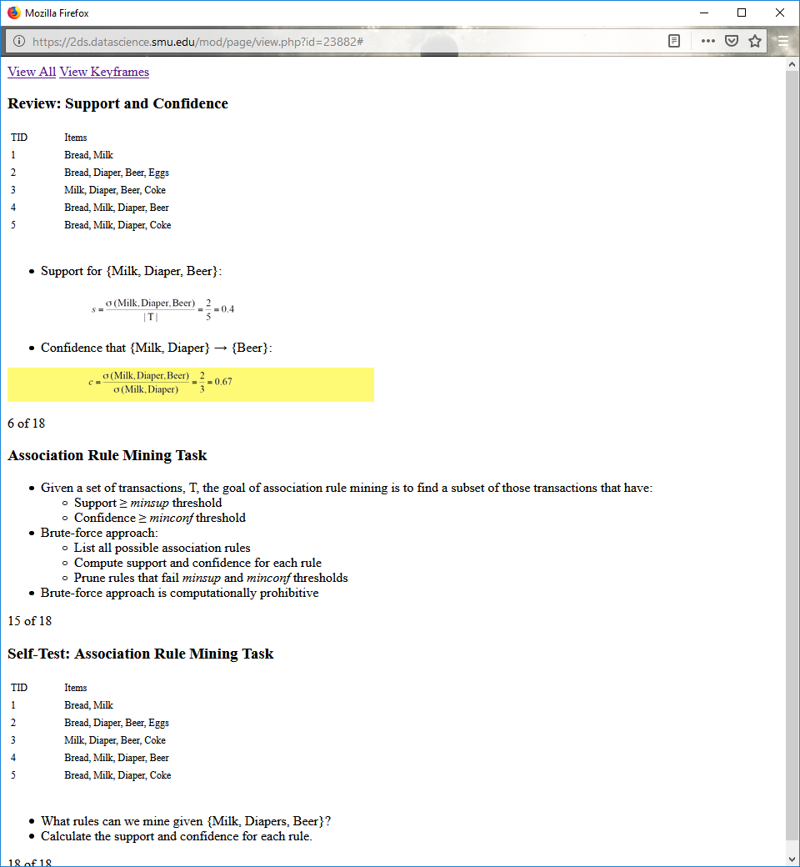

**Association Rule Mining Task**

Given a set of transactions, T, the goal of association rule mining is to find a subset of those transactions that have:

Support ≥ *minsup* threshold

Confidence ≥ *minconf* threshold

Brute-force approach:

List all possible association rules

Compute support and confidence for each rule

Prune rules that fail *minsup* and *minconf* thresholds

Brute-force approach is computationally prohibitive

**Self-Test: Association Rule Mining Task**

|  |  |
| --- | --- |
| **TID** | **Items** |
| 1 | Bread, Milk |
| 2 | Bread, Diaper, Beer, Eggs |
| 3 | Milk, Diaper, Beer, Coke |
| 4 | Bread, Milk, Diaper, Beer |
| 5 | Bread, Milk, Diaper, Coke |

What rules can we mine given {Milk, Diapers, Beer}?

Calculate the support and confidence for each rule.

**Answers to Self-Test**

What rules can be mined for {Milk, Diaper, Beer}?

We can generate six rules from the itemset:

{Milk, Diaper} → {Beer} (s = 0.4, c = 0.67)

{Milk, Beer} → {Diaper} (s = 0.4, c = 1.0)

{Diaper, Beer} → {Milk} (s = 0.4, c = 0.67)

{Beer} → {Milk, Diaper} (s = 0.4, c = 0.67)

{Diaper} → {Milk, Beer} (s = 0.4, c = 0.5)

{Milk} → {Diaper, Beer} (s = 0.4, c = 0.5)

All the rules had the same support (0.4) but different confidences.

Support and confidence requirements can be decoupled.

**Decoupling Support and Confidence**

Two-step approach:

1. Frequent itemset generation: calculate all itemsets whose support ≥ minsup

2. Rule generation: calculate confidence rules from each frequent itemset, where each rule is a binary partitioning of a frequent itemset

**Frequent itemset generation (step 1) is still computationally expensive.**

**12.4**

**Frequent Itemset Candidate Lattice**

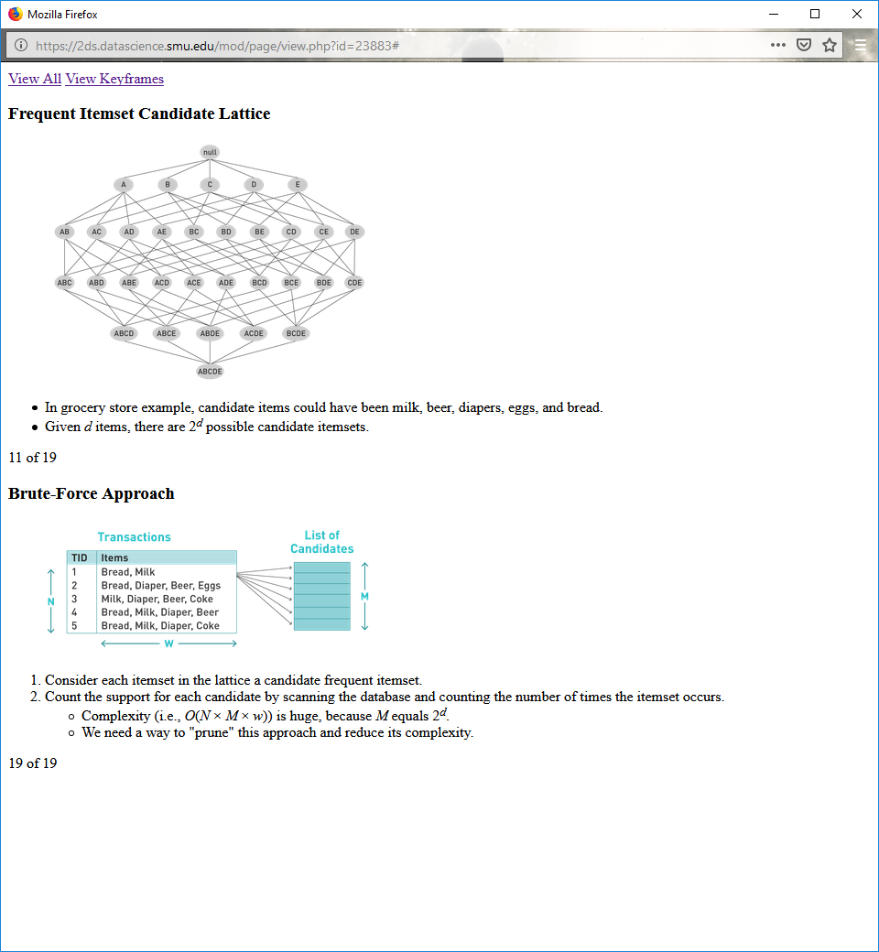

In grocery store example, candidate items could have been milk, beer, diapers, eggs, and bread.

Given *d* items, there are 2*d* possible candidate itemsets.

**Brute-Force Approach**



1. Consider each itemset in the lattice a candidate frequent itemset.

2. Count the support for each candidate by scanning the database and counting the number of times the itemset occurs.

Complexity (i.e., *O*(*N* × *M* × *w*)) is huge, because *M* equals 2*d*.

We need a way to "prune" this approach and reduce its complexity.

**Three Ways to Reduce Complexity**

1. Reduce number of candidates (*M*)

2. Reduce number of transactions (*N*)

Difficult but possible given the right domain knowledge

3. Reduce number of comparisons (*NM*)

Involves using efficient data structures to eliminate need to match every candidate against every transaction

**Apriori Principle**

Says that if an itemset is frequent, all its subsets also must be frequent

Holds due to the **anti-monotone** property of support:

∀ *X*, *Y* : (*X* ⊆ *Y*) → *s*(*X*) ≥ *s*(*Y*)

Support of an itemset never exceeds the support of its subsets

**Illustrating Apriori Principle**

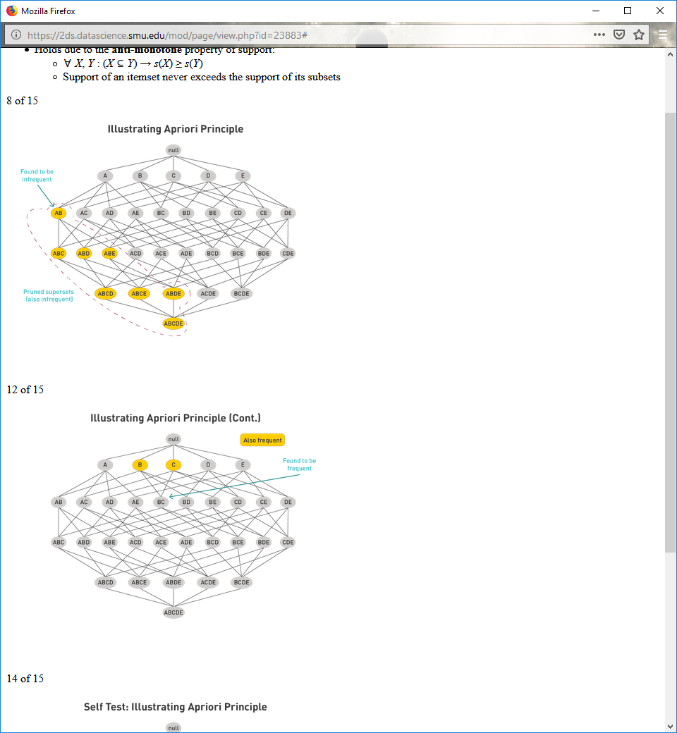

**Illustrating Apriori Principle (Cont.)**



**Self Test: Illustrating Apriori Principle**

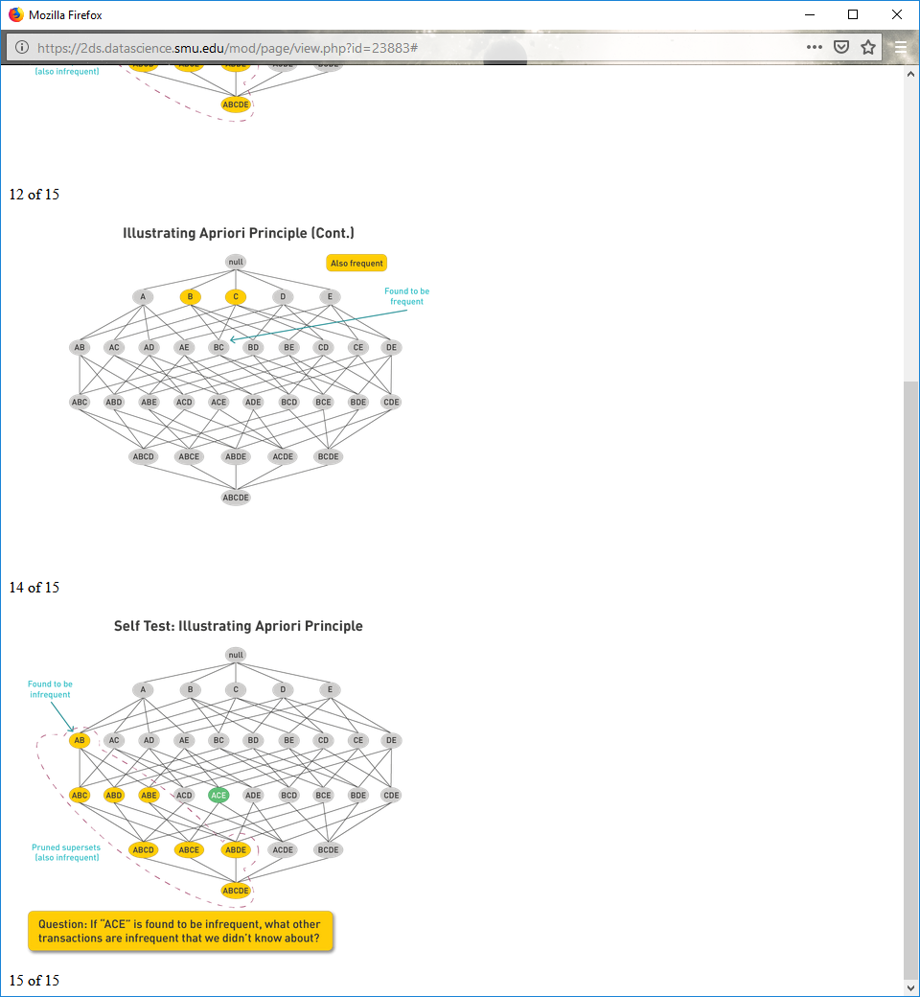

**Illustrating Apriori Principle**

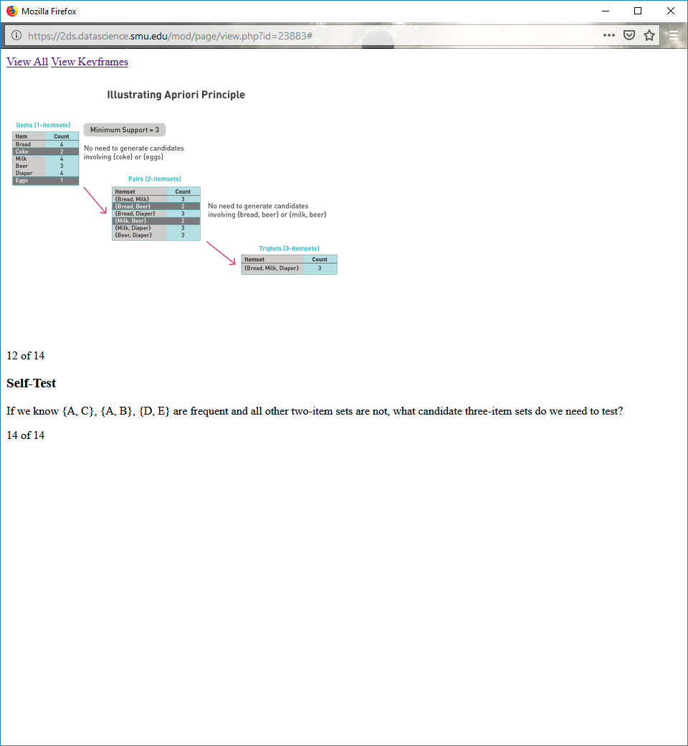

**Self-Test**

If we know {A, C}, {A, B}, {D, E} are frequent and all other two-item sets are not, what candidate three-item sets do we need to test?

**Apriori Algorithm: Method**

Let *k* = 1.

Generate frequent itemsets of length 1.

Repeat until no new frequent itemsets are identified:

Generate length (*k* + 1) candidate itemsets from length *k* frequent itemsets.

Prune candidate itemsets containing subsets of length *k* that are infrequent.

Count the support for each candidate by scanning the database.

Eliminate candidates that are infrequent, leaving only those that are frequent.

**Reducing Number of Comparisons**

A **hash tree** is used to reduce the number of comparisons.

The support of each *k* frequent itemset candidate is calculated by comparing it to every one of the transactions in the database.

This comparison needs to be efficient.

**Generating a Hash Tree**

Suppose you have 15 candidate itemsets of length three:

{1 4 5}, {1 2 4}, {4 5 7}, {1 2 5}, {4 5 8}, {1 5 9}, {1 3 6}, {2 3 4},   
{5 6 7}, {3 4 5}, {3 5 6}, {3 5 7}, {6 8 9}, {3 6 7}, {3 6 8}

Generate a hash tree based on this hash function:

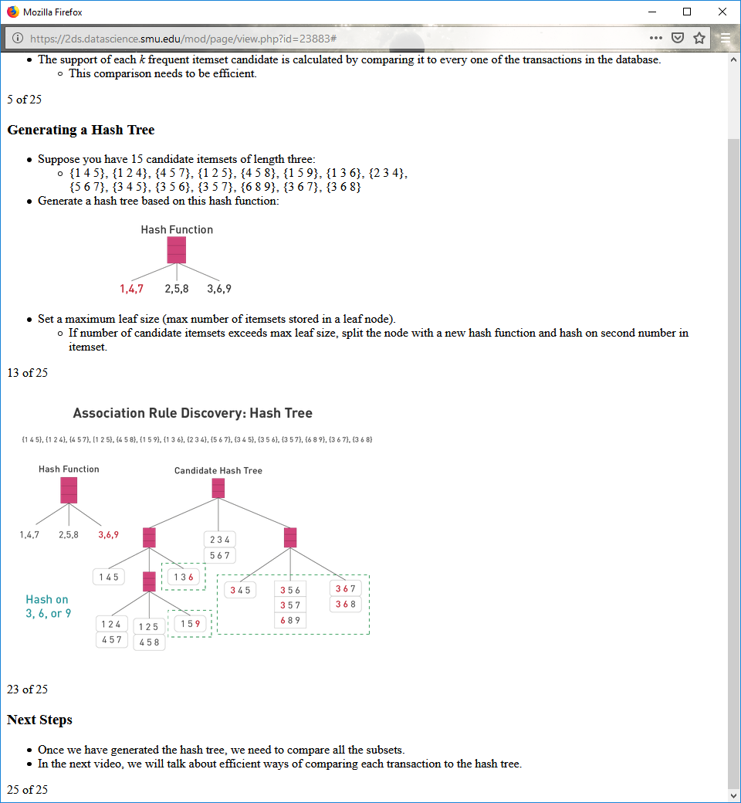

Set a maximum leaf size (max number of itemsets stored in a leaf node).

If number of candidate itemsets exceeds max leaf size, split the node with a new hash function and hash on second number in itemset.

**Association Rule Discovery: Hash Tree**



**Next Steps**

Once we have generated the hash tree, we need to compare all the subsets.

In the next video, we will talk about efficient ways of comparing each transaction to the hash tree.

**Subset Operation**

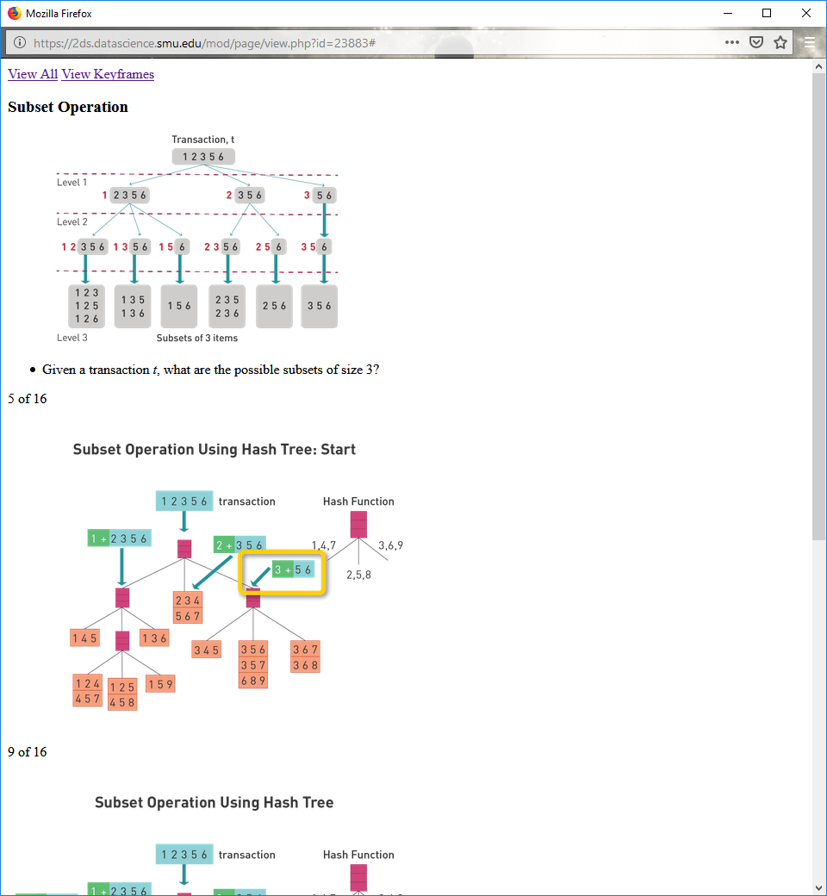

Given a transaction *t*, what are the possible subsets of size 3?

**Subset Operation Using Hash Tree: Start**



**Subset Operation Using Hash Tree**

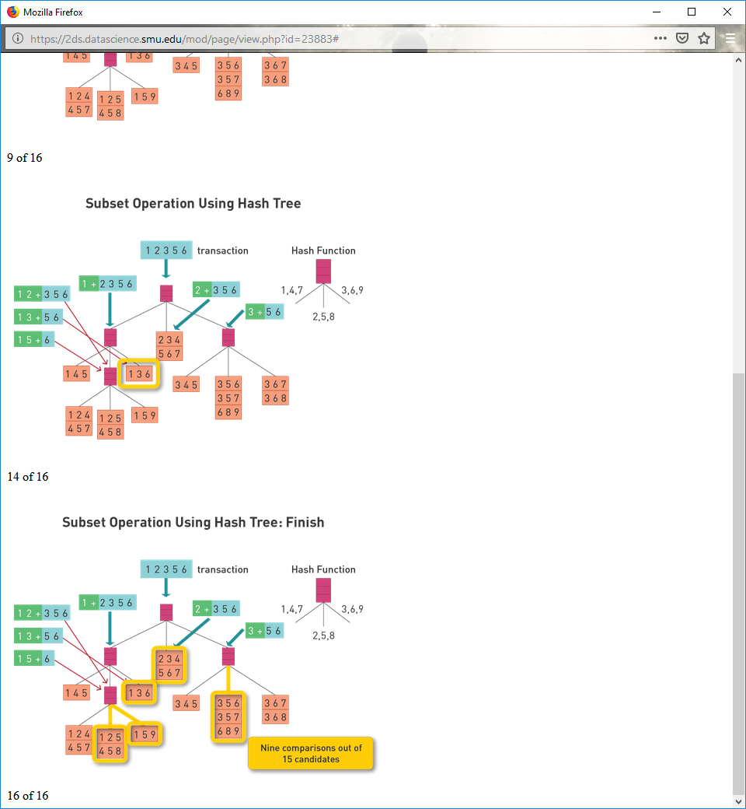

**Subset Operating Using Hash Tree: Finish**



**Overall Complexity**

Before Apriori algorithm: *O*(*N* × *M* × *w*)

After Apriori algorithm: cannot be calculated exactly

**Factors That Affect Complexity**

Dimensionality (number of items in data set)

If number of frequent items increases, size of candidate lattice increases.

Size of database

Apriori makes multiple passes, so run time may increase as number of transactions increases.

**Factors That Affect Complexity**

Dimensionality (number of items in data set)

If number of frequent items increases, size of candidate lattice increases.

Size of database

Apriori makes multiple passes, so run time may increase as number of transactions increases.

Average transaction width (number of items in each transaction)

Number of items in each transaction affects number of hash tree traversals.

Choice of minimum support threshold

Too low of a threshold may result in too many frequent itemsets.

Too high of a threshold may result in missed itemsets.

**12.5**

**FP-Growth Algorithm**

The Apriori method requires multiple passes over a data set, which requires significant computational time for extremely large data sets.

A **frequent-pattern tree (FP-tree**) creates a compressed representation of the database with only two passes over the data set.

We then mine the frequent itemsets using graphical cuts over the tree.

**FP-Tree Construction: Pass 1**

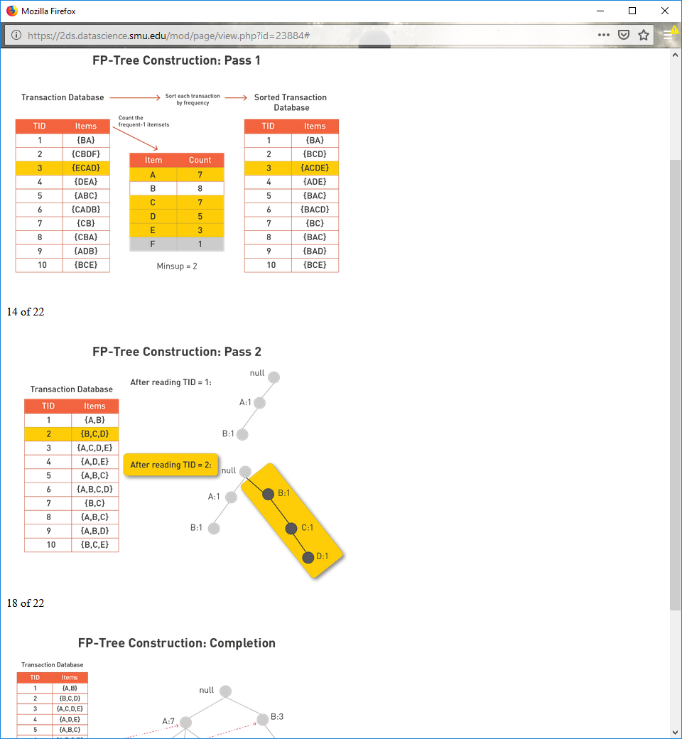

**FP-Tree Construction: Pass 2**



**FP-Tree Construction: Completion**

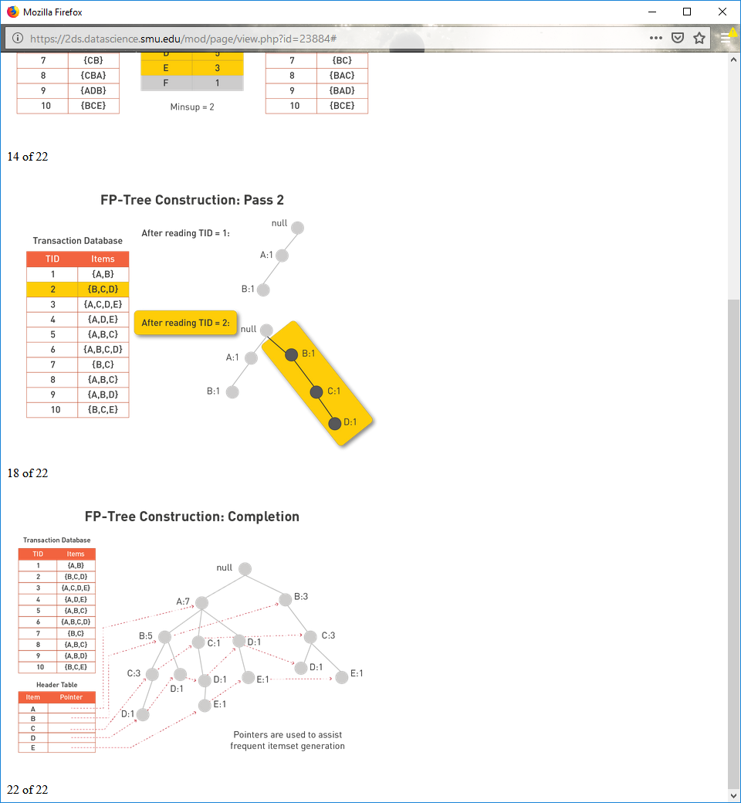

**Self Test**

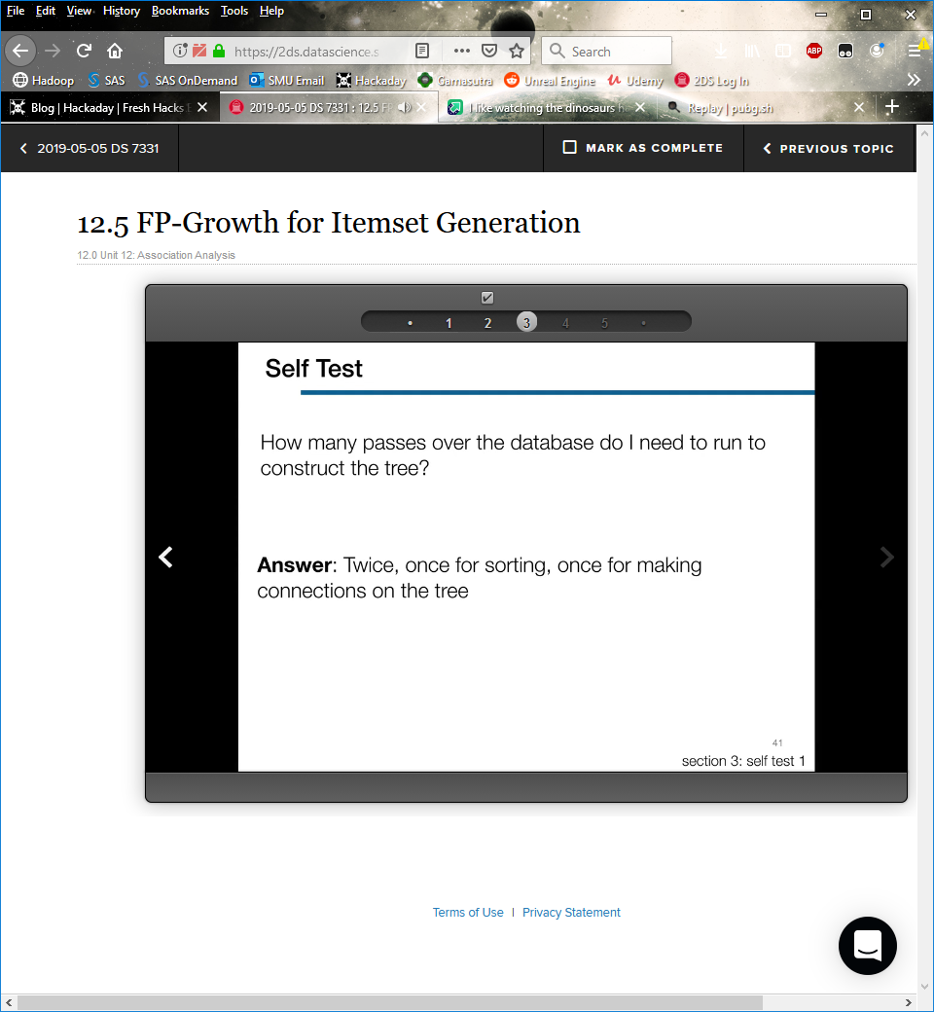

**FP-Tree Divide and Conquer**

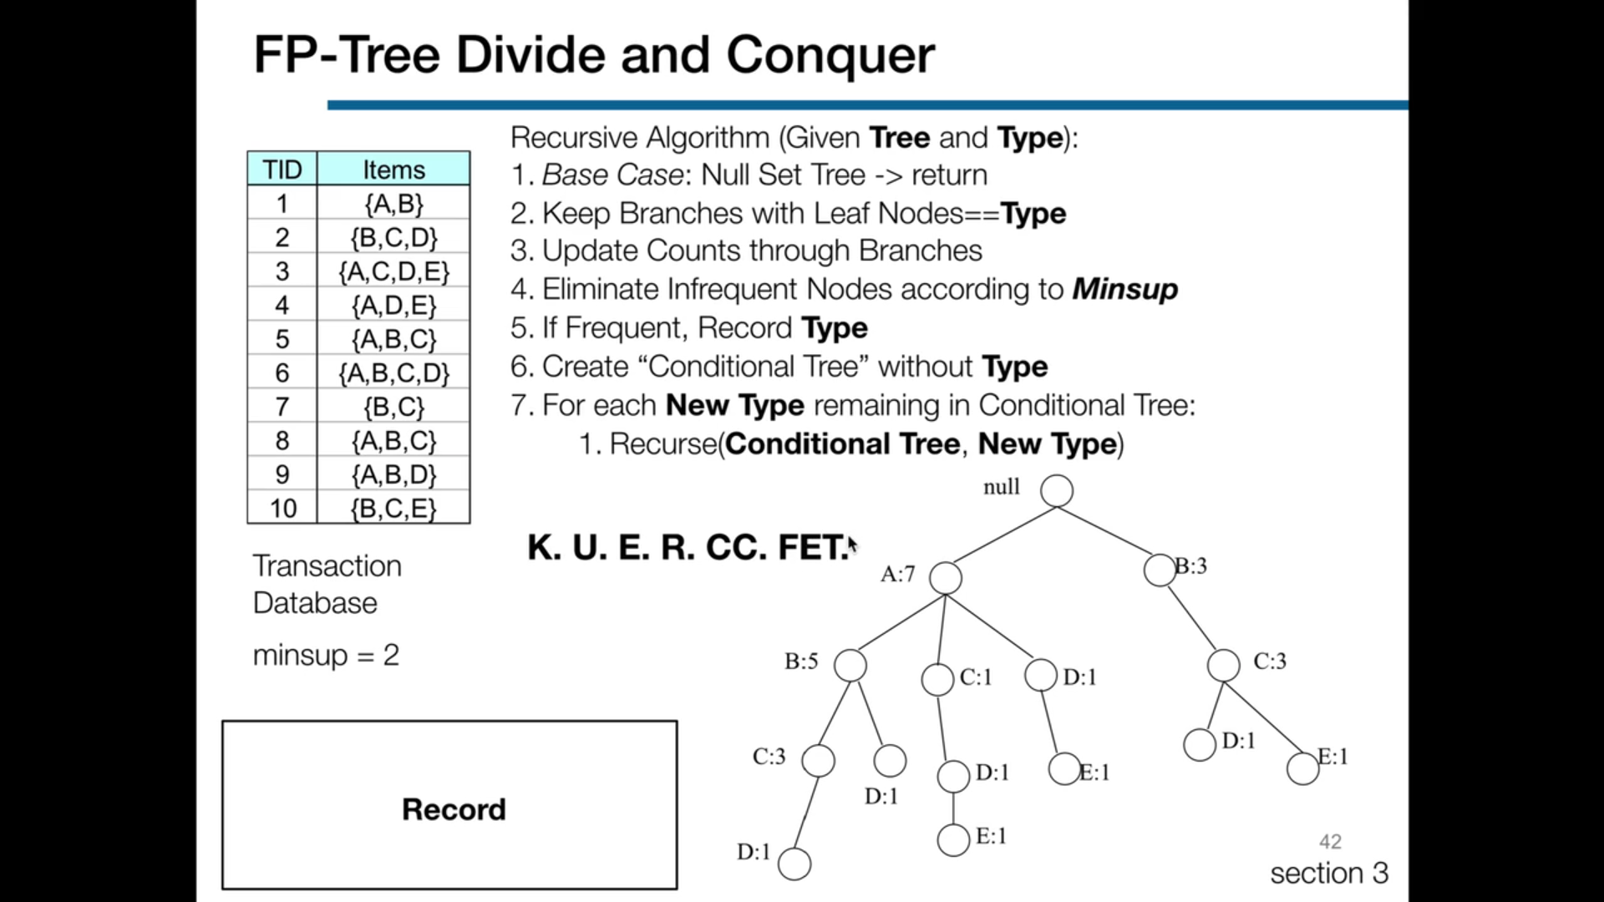

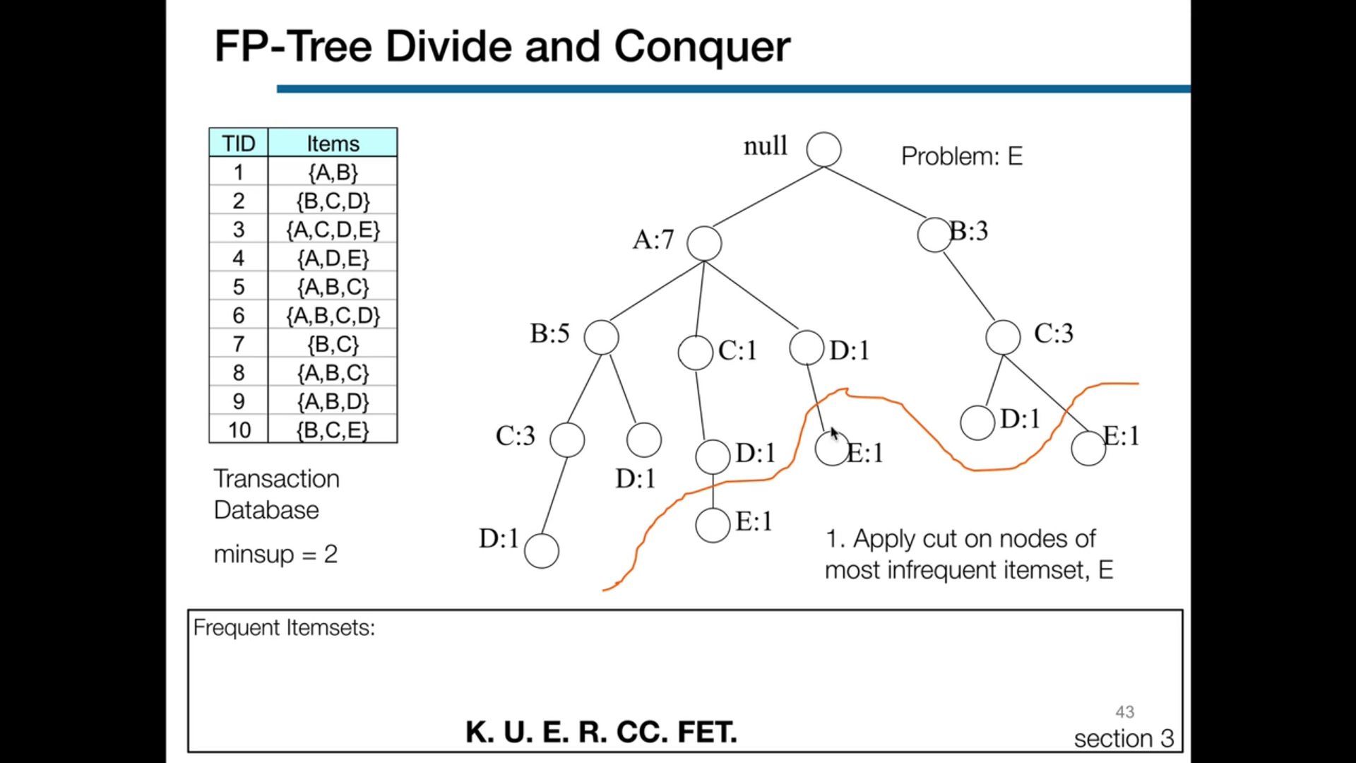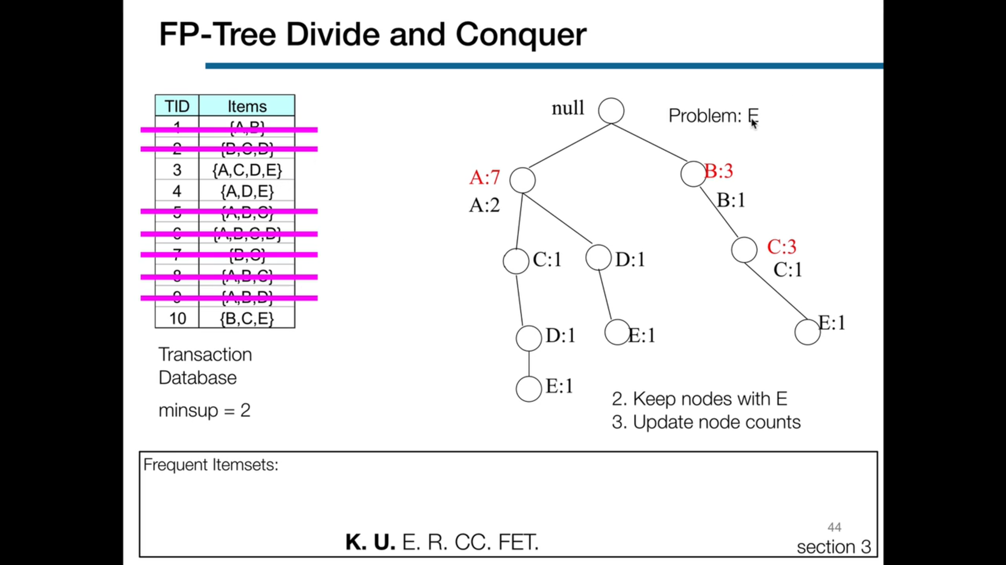

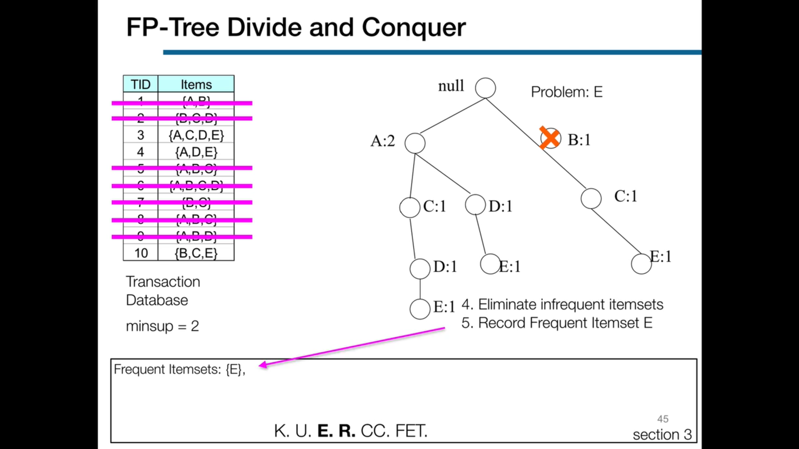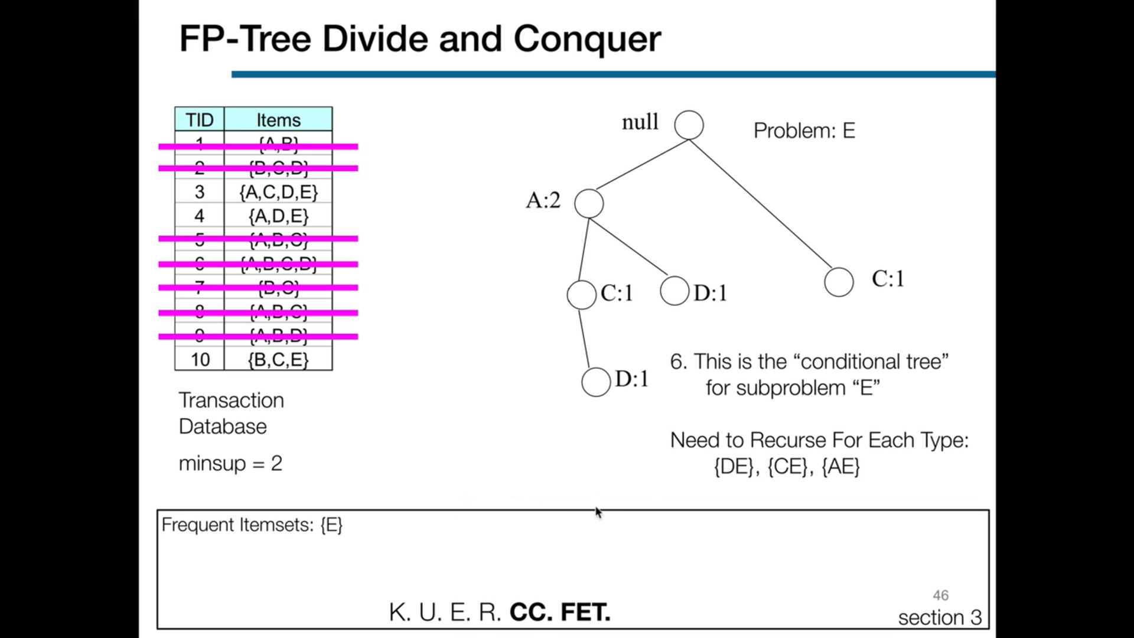

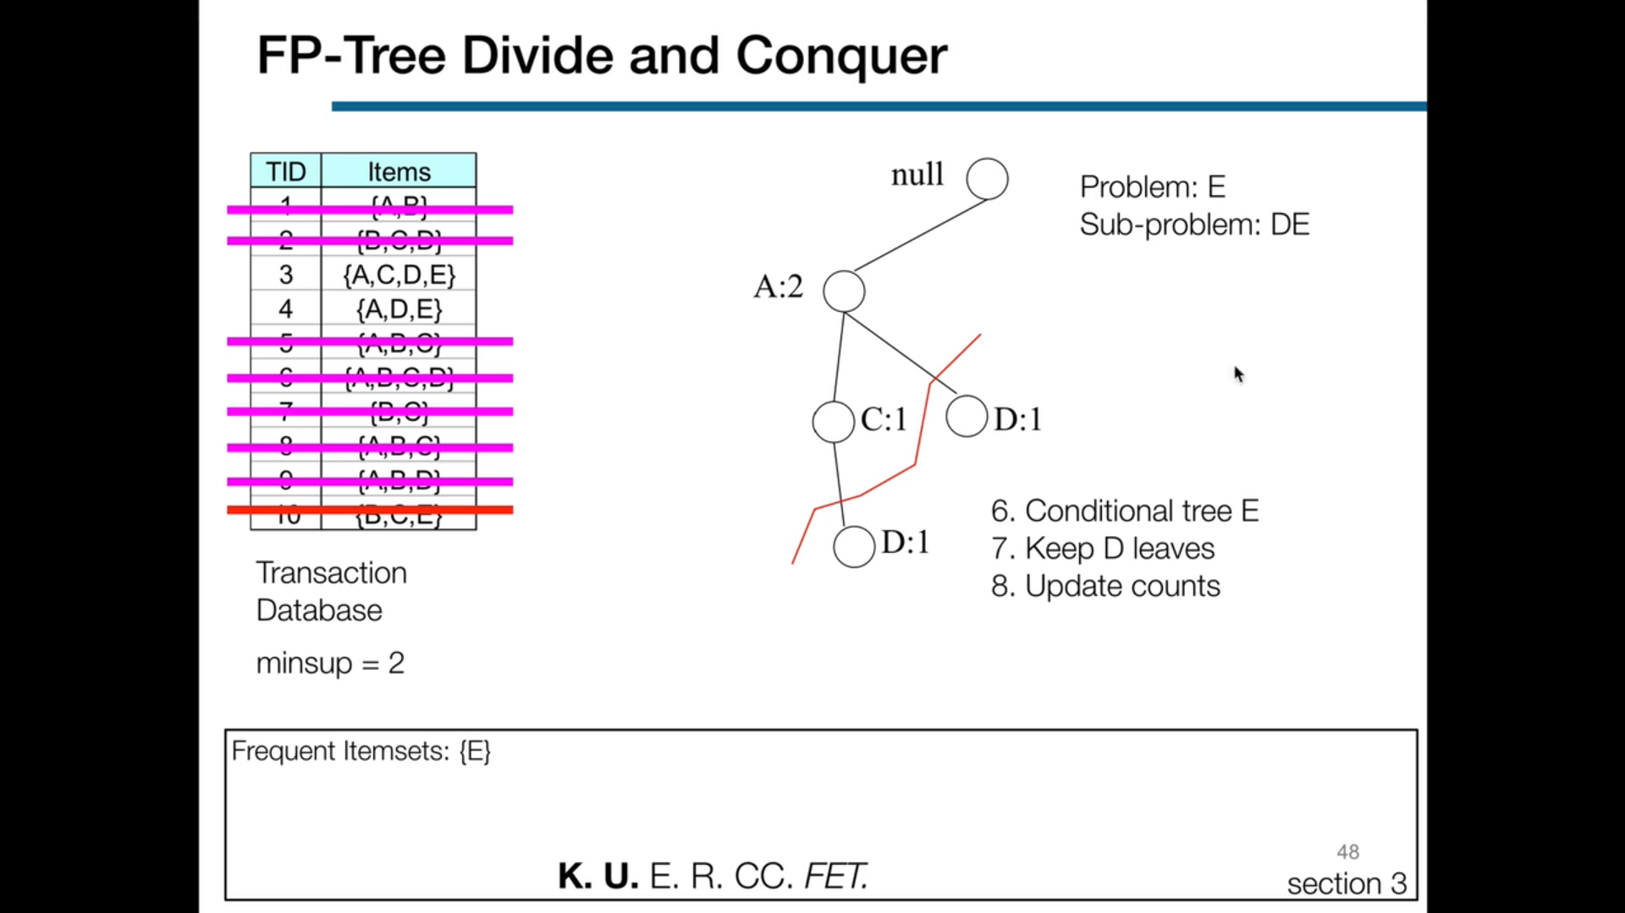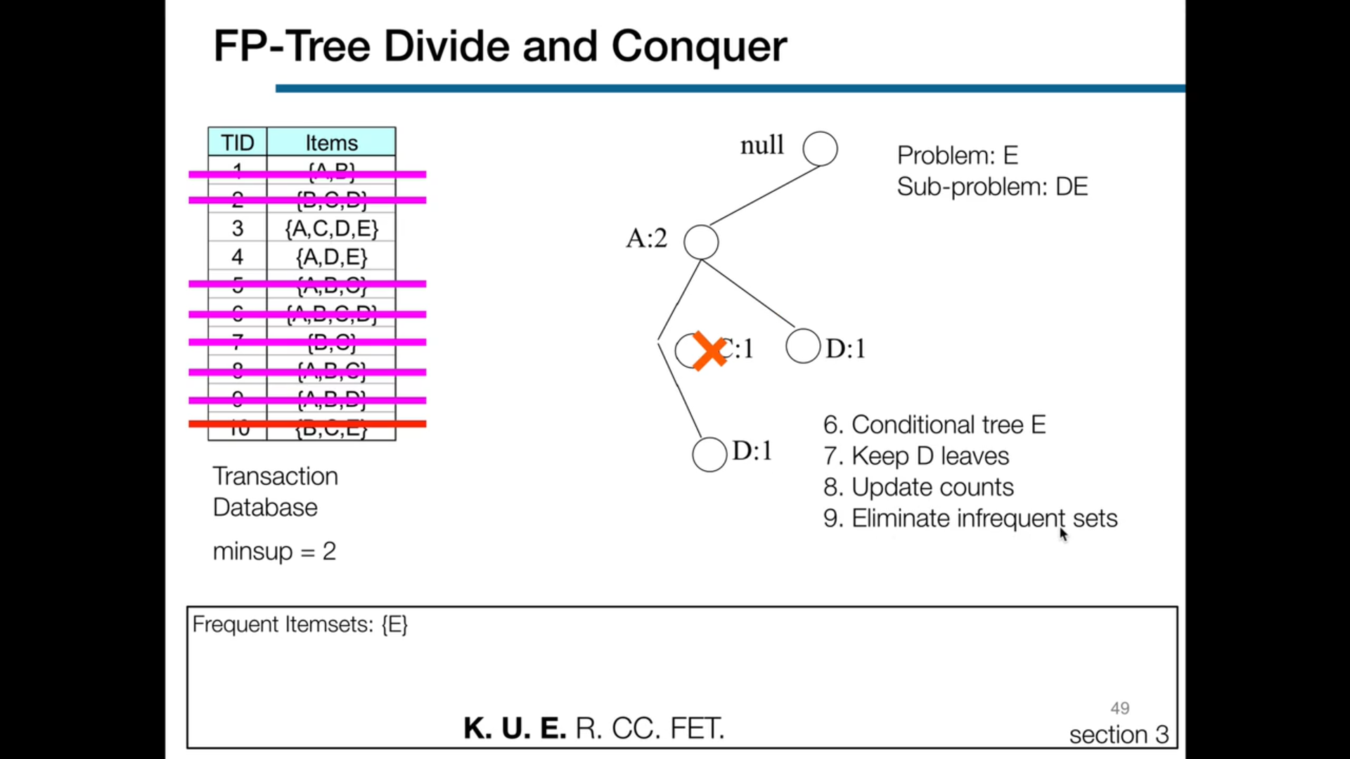

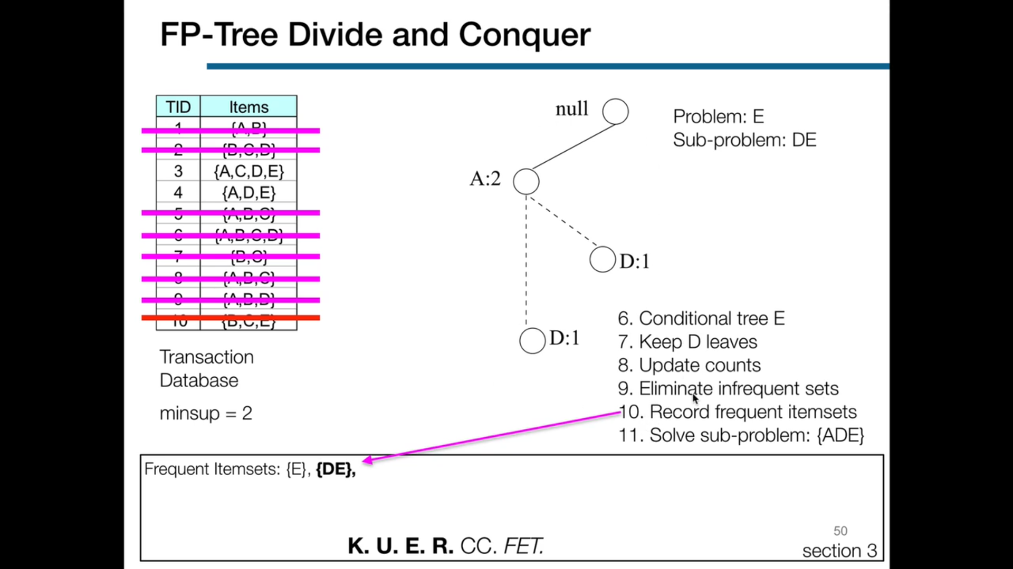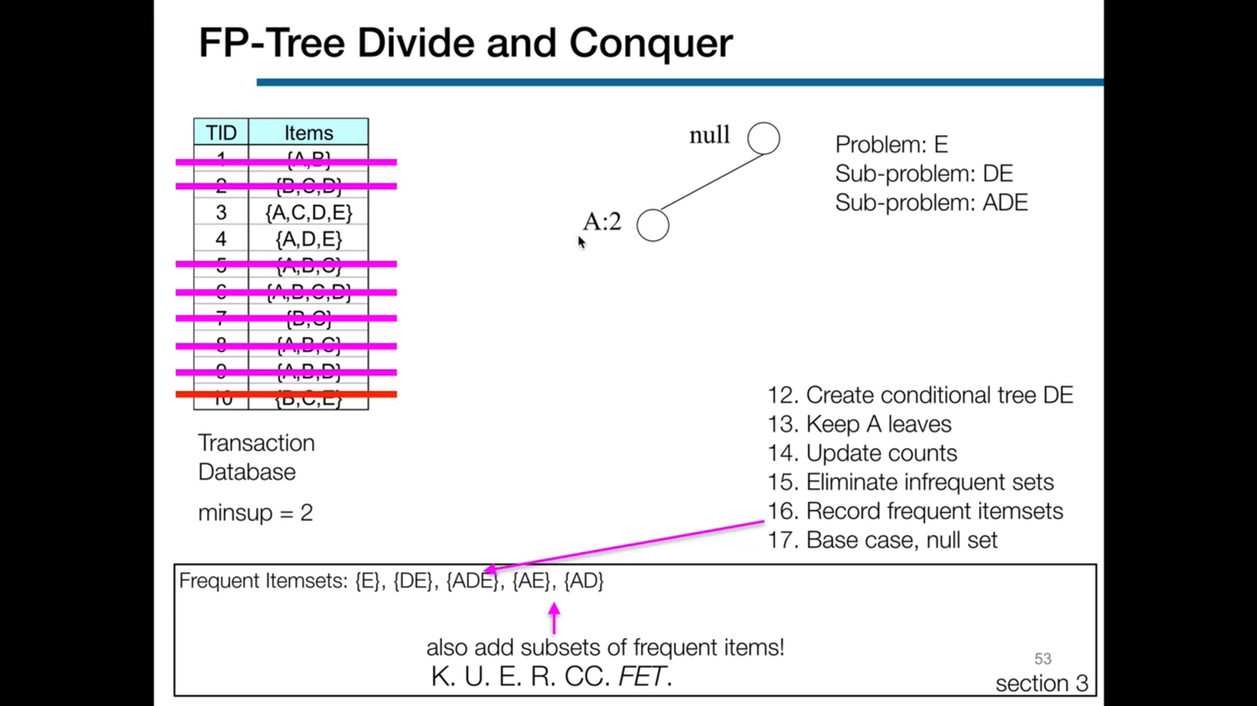

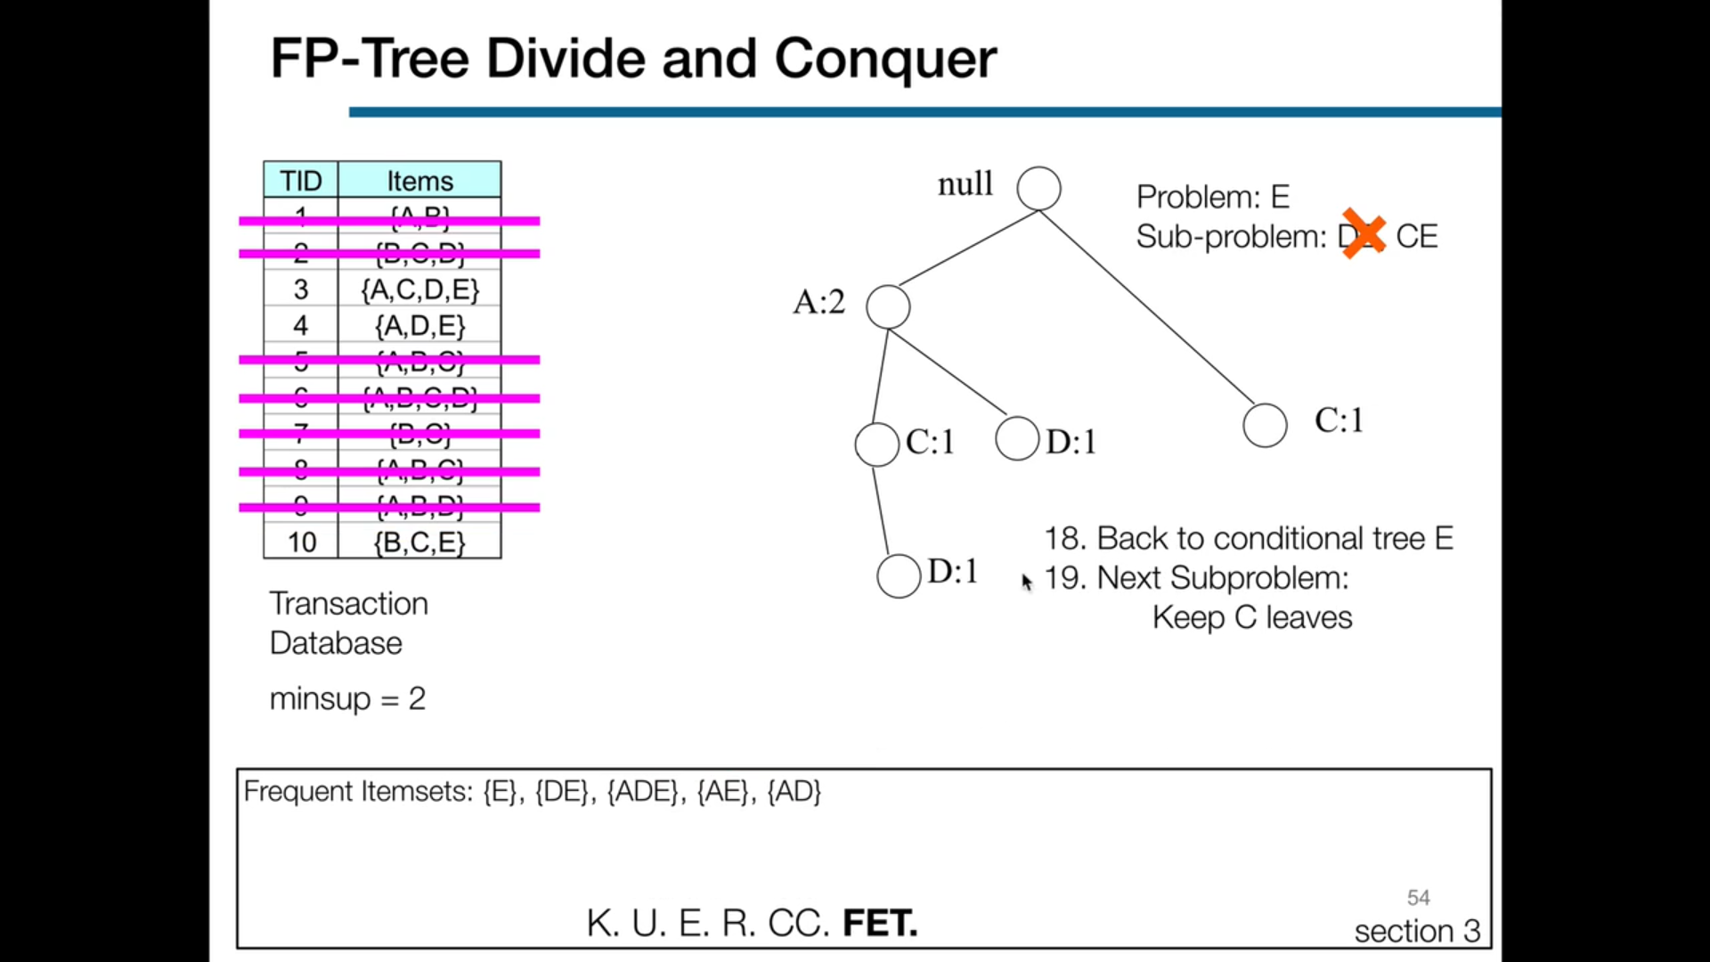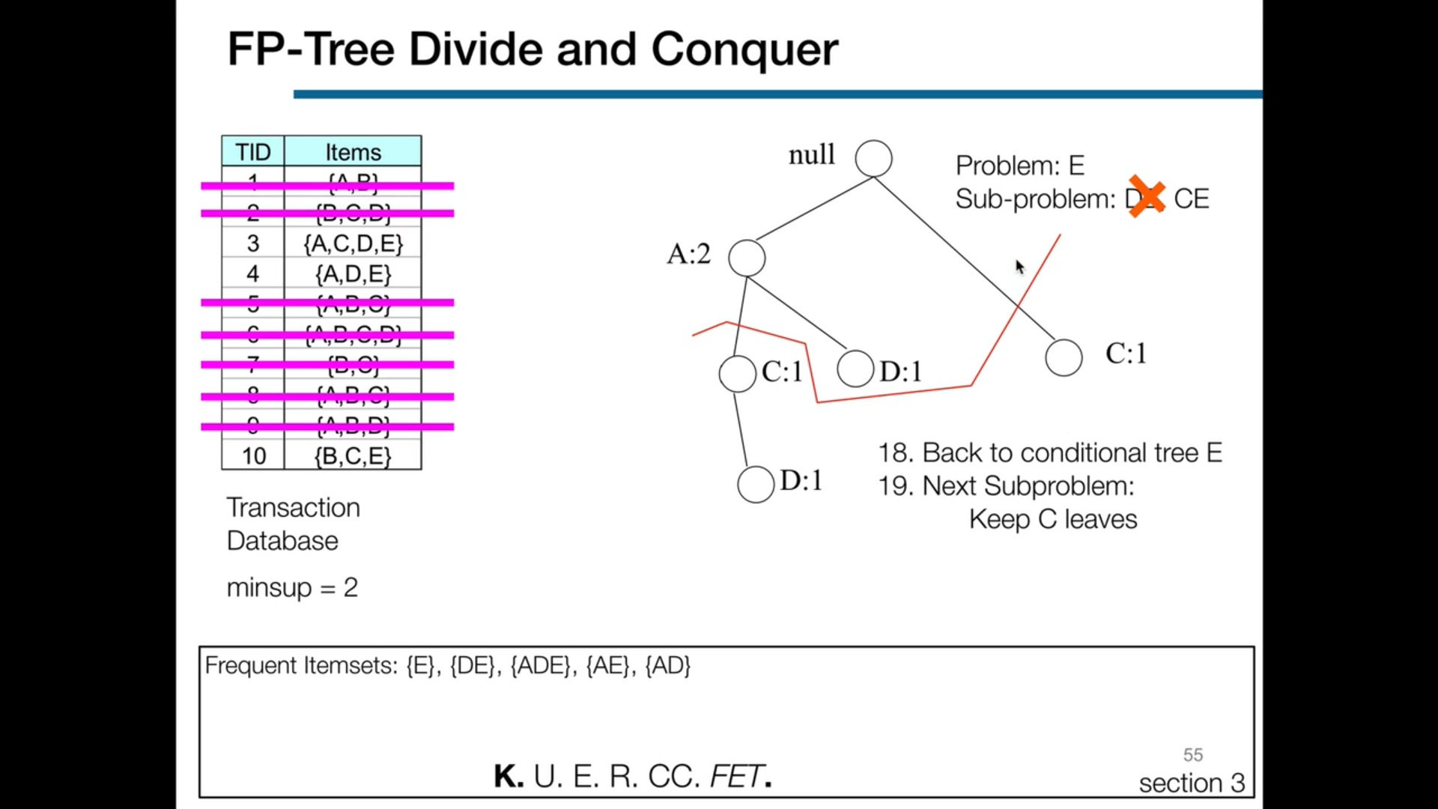

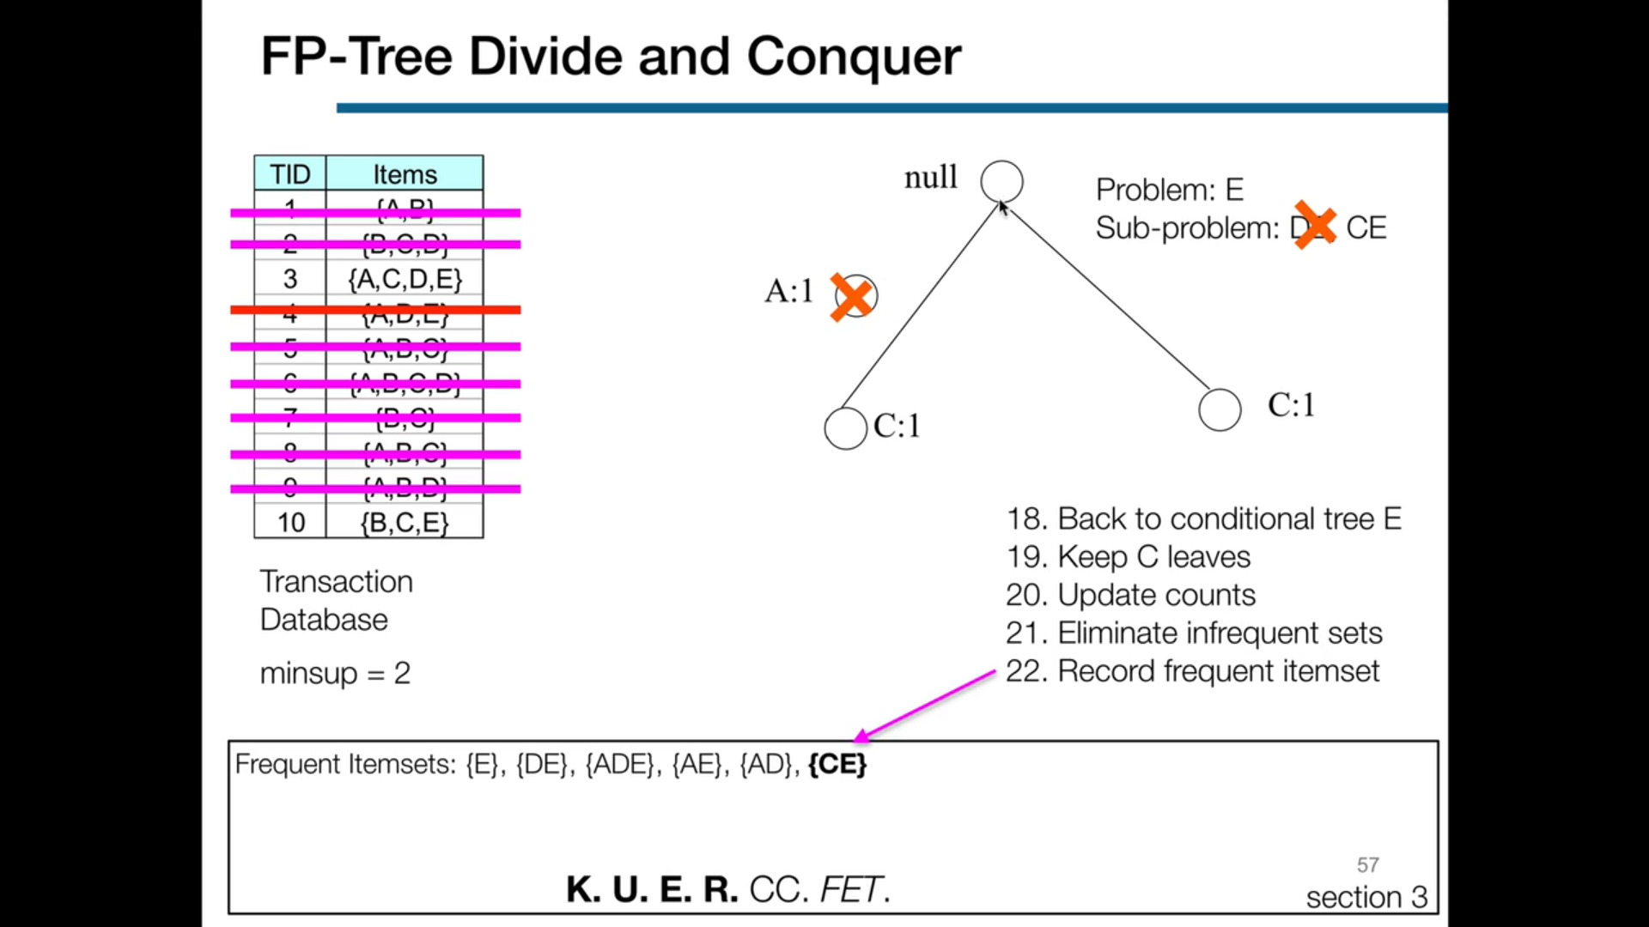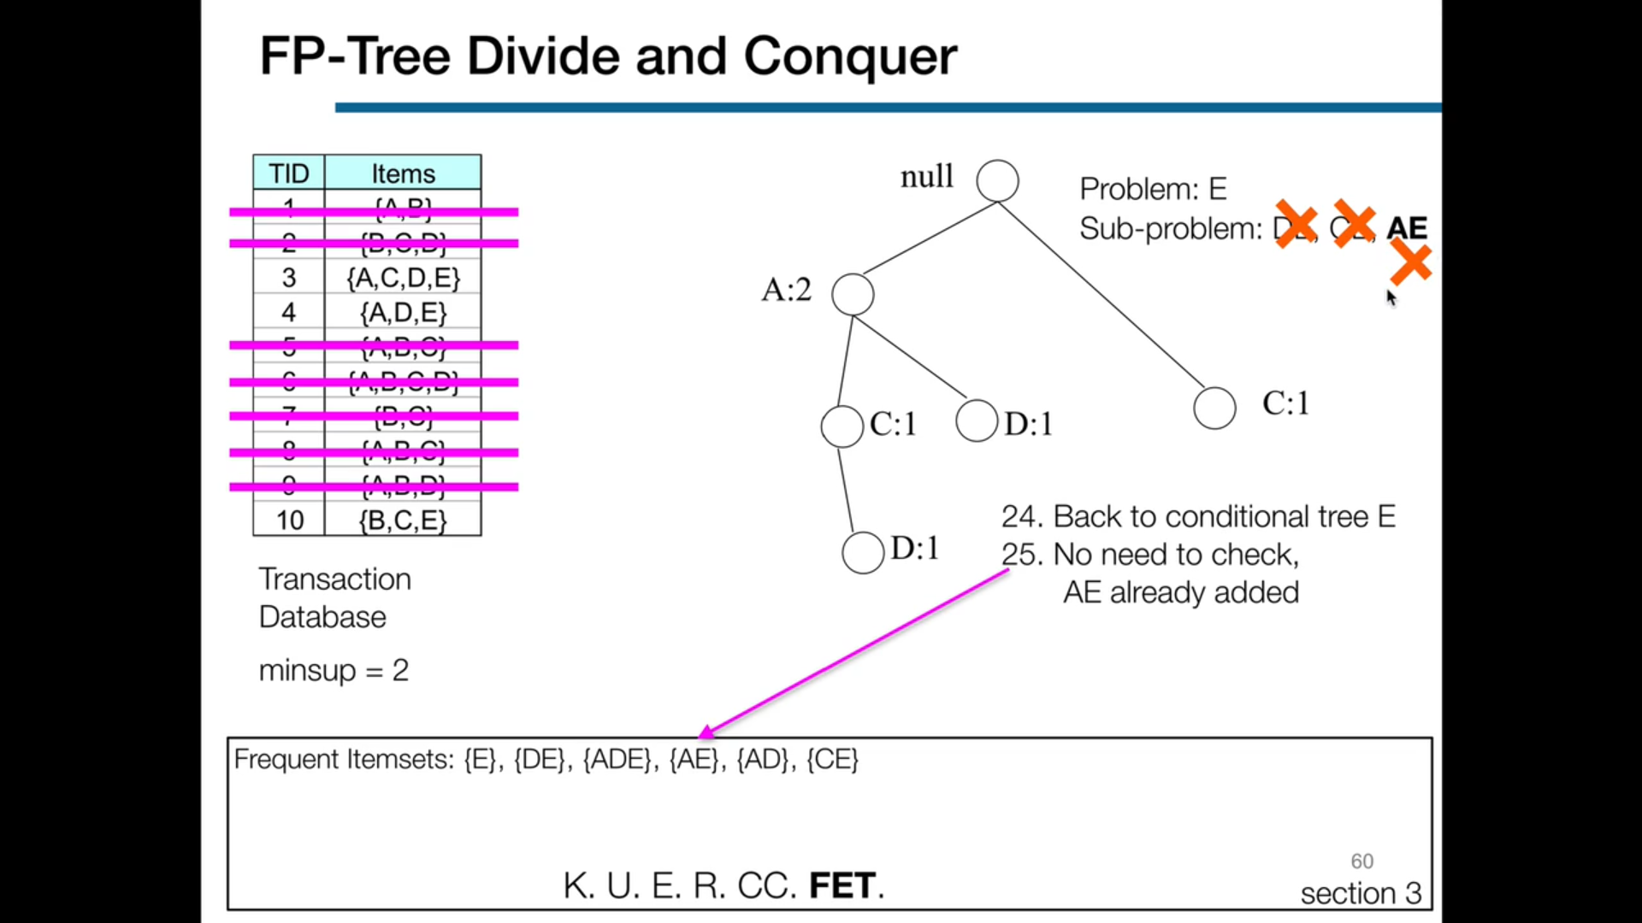

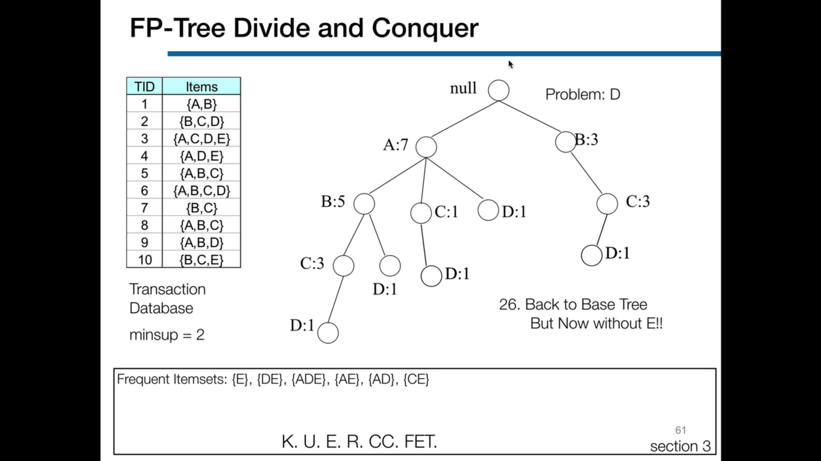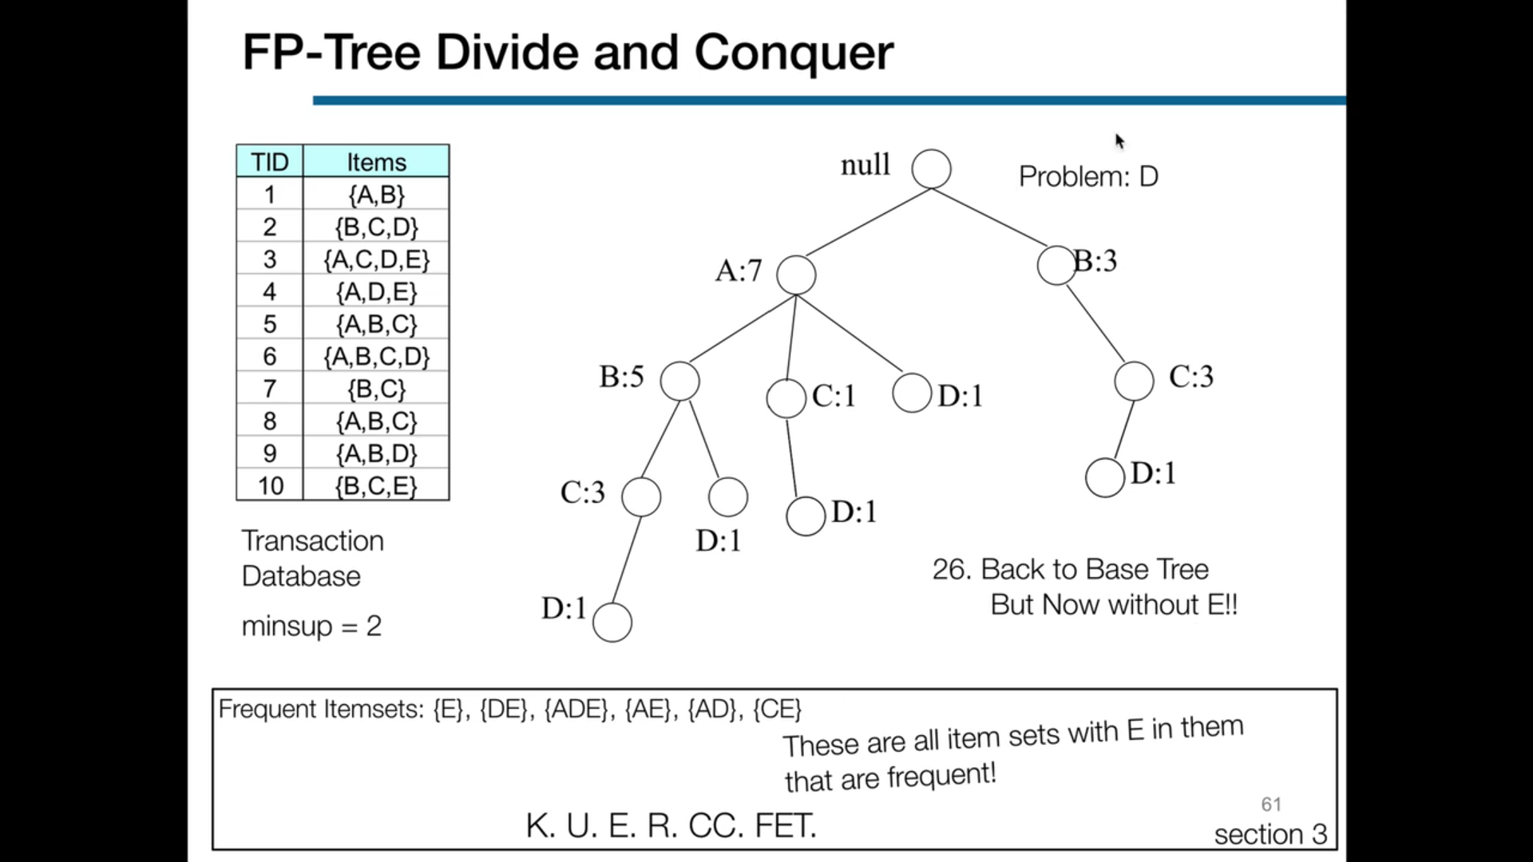

**SELF TEST**

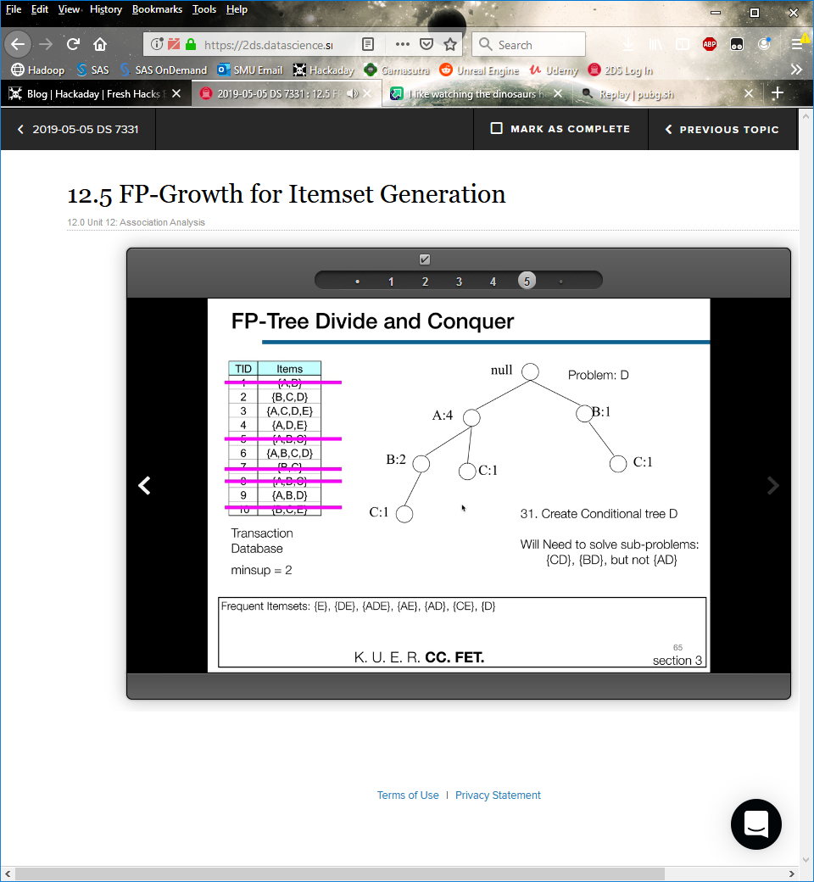

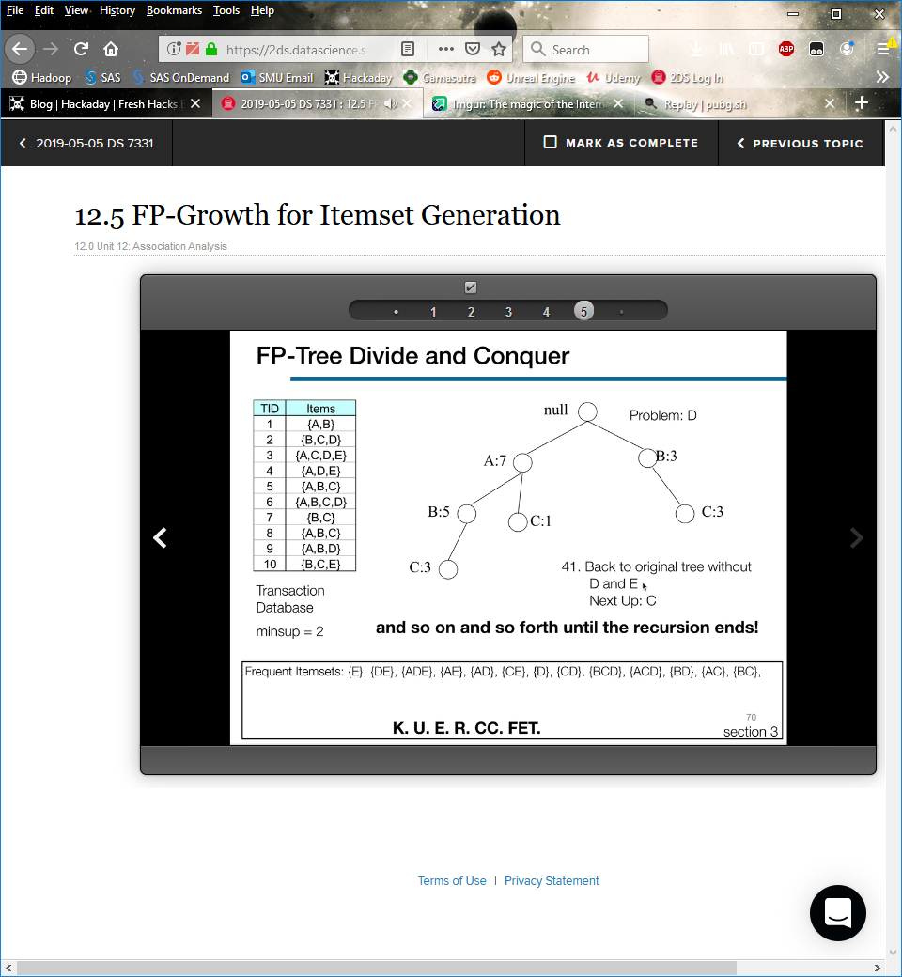

**12.6**

**Association Rule Mining**

Recall our two tasks:

Calculate frequent itemsets

Calculate and mine rules

Given a frequent itemset, how can we find all rules from that frequent itemset with confidence ≥ *minconf*?

**Rule Generation**

Given a frequent itemset *L*, find all nonempty subsets *f* ⊂ *L* such that *f* implies that *L* − *f* satisfies the minimum confidence requirement.

E.g., if {A,B,C,D} is a frequent itemset, candidate rules are:

|  |  |  |  |  |  |
| --- | --- | --- | --- | --- | --- |
|  | ABC → D | ABD → C | ACD → B | BCD → A |  |
|  | A → BCD | B → ACD | C → ABD | D → ABC |  |
|  | AB → CD | AC → BD | AD → BC | BC → AD |  |
|  | BD → AC | CD → AB |  |  |  |

If |L| = *k*, then there are 2*k* − 2 candidate association rules (i.e., we ignore *L* → ∅ and ∅ → *L*).

**Rule Generation Efficiency**

In general, confidence does not have an anti-monotone property.

For example, *c*(ABC → D) can be larger or smaller than *c*(AB → D).

But confidence of rules generated from the same itemset *does* have an **anti-monotone** property.

E.g., for *L* = {A,B,C,D}:

*c*(ABC → D) ≥ *c*(AB → CD) ≥ *c*(A → BCD)

**Confidence** is **anti-monotone** with regard to the number of items on the right hand side of the rule.

**Rule Generation Lattice for Apriori ALgorithm**

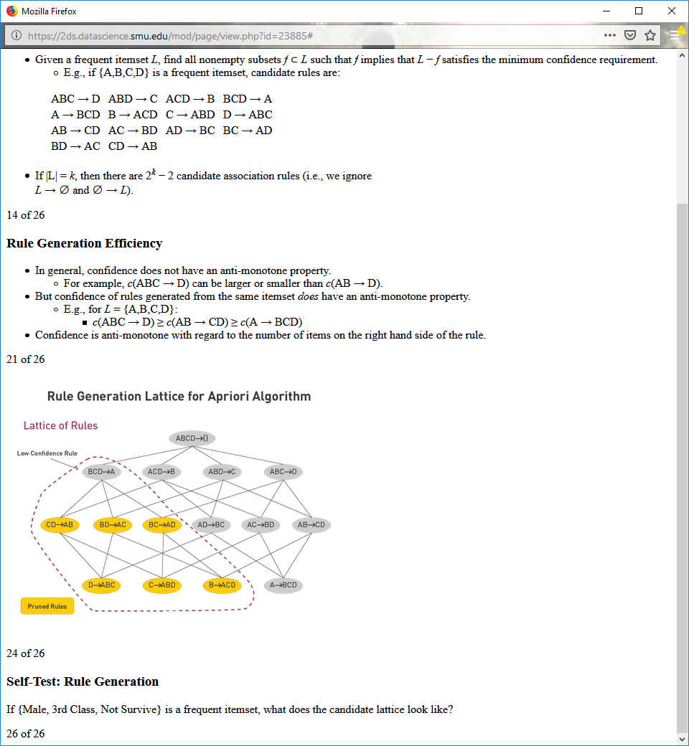

**Self-Test: Rule Generation**

If {Male, 3rd Class, Not Survive} is a frequent itemset, what does the candidate lattice look like?

**Apriori Algorithm**

Can generate frequent itemsets based on other frequent itemsets

E.g., generating frequent *k* + 1 itemsets based on frequent *k* itemsets

Can also merge *rules* to form new candidate rules

**Rule Generation with Apriori Algorithm** 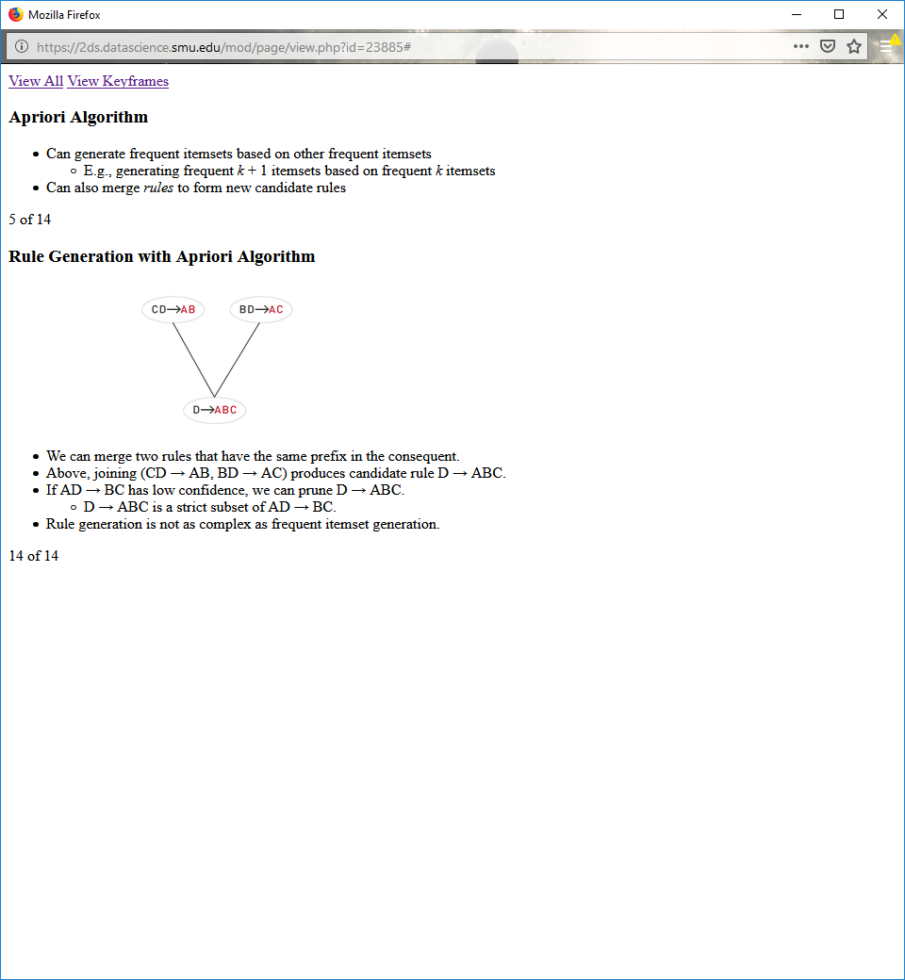

We can merge two rules that have the same prefix in the consequent.

Above, joining (CD → AB, BD → AC) produces candidate rule D → ABC.

If AD → BC has low confidence, we can prune D → ABC.

D → ABC is a strict subset of AD → BC.

Rule generation is not as complex as frequent itemset generation.

**12.7**

**Compact Representation of Frequent Itemsets**

|  |  |  |  |  |  |  |  |  |  |  |  |  |  |  |  |  |  |  |  |  |  |  |  |  |  |  |  |  |  |  |
| --- | --- | --- | --- | --- | --- | --- | --- | --- | --- | --- | --- | --- | --- | --- | --- | --- | --- | --- | --- | --- | --- | --- | --- | --- | --- | --- | --- | --- | --- | --- |
| TID | A1 | A2 | A3 | A4 | A5 | A6 | A7 | A8 | A9 | A10 | B1 | B2 | B3 | B4 | B5 | B6 | B7 | B8 | B9 | B10 | C1 | C2 | C3 | C4 | C5 | C6 | C7 | C8 | C9 | C10 |
| 1 | 1 | 1 | 1 | 1 | 1 | 1 | 1 | 1 | 1 | 1 | 0 | 0 | 0 | 0 | 0 | 0 | 0 | 0 | 0 | 0 | 0 | 0 | 0 | 0 | 0 | 0 | 0 | 0 | 0 | 0 |
| 2 | 1 | 1 | 1 | 1 | 1 | 1 | 1 | 1 | 1 | 1 | 0 | 0 | 0 | 0 | 0 | 0 | 0 | 0 | 0 | 0 | 0 | 0 | 0 | 0 | 0 | 0 | 0 | 0 | 0 | 0 |
| 3 | 1 | 1 | 1 | 1 | 1 | 1 | 1 | 1 | 1 | 1 | 0 | 0 | 0 | 0 | 0 | 0 | 0 | 0 | 0 | 0 | 0 | 0 | 0 | 0 | 0 | 0 | 0 | 0 | 0 | 0 |
| 4 | 1 | 1 | 1 | 1 | 1 | 1 | 1 | 1 | 1 | 1 | 0 | 0 | 0 | 0 | 0 | 0 | 0 | 0 | 0 | 0 | 0 | 0 | 0 | 0 | 0 | 0 | 0 | 0 | 0 | 0 |
| 5 | 1 | 1 | 1 | 1 | 1 | 1 | 1 | 1 | 1 | 1 | 0 | 0 | 0 | 0 | 0 | 0 | 0 | 0 | 0 | 0 | 0 | 0 | 0 | 0 | 0 | 0 | 0 | 0 | 0 | 0 |
| 6 | 0 | 0 | 0 | 0 | 0 | 0 | 0 | 0 | 0 | 0 | 1 | 1 | 1 | 1 | 1 | 1 | 1 | 1 | 1 | 1 | 0 | 0 | 0 | 0 | 0 | 0 | 0 | 0 | 0 | 0 |
| 7 | 0 | 0 | 0 | 0 | 0 | 0 | 0 | 0 | 0 | 0 | 1 | 1 | 1 | 1 | 1 | 1 | 1 | 1 | 1 | 1 | 0 | 0 | 0 | 0 | 0 | 0 | 0 | 0 | 0 | 0 |
| 8 | 0 | 0 | 0 | 0 | 0 | 0 | 0 | 0 | 0 | 0 | 1 | 1 | 1 | 1 | 1 | 1 | 1 | 1 | 1 | 1 | 0 | 0 | 0 | 0 | 0 | 0 | 0 | 0 | 0 | 0 |
| 9 | 0 | 0 | 0 | 0 | 0 | 0 | 0 | 0 | 0 | 0 | 1 | 1 | 1 | 1 | 1 | 1 | 1 | 1 | 1 | 1 | 0 | 0 | 0 | 0 | 0 | 0 | 0 | 0 | 0 | 0 |
| 10 | 0 | 0 | 0 | 0 | 0 | 0 | 0 | 0 | 0 | 0 | 1 | 1 | 1 | 1 | 1 | 1 | 1 | 1 | 1 | 1 | 0 | 0 | 0 | 0 | 0 | 0 | 0 | 0 | 0 | 0 |
| 11 | 0 | 0 | 0 | 0 | 0 | 0 | 0 | 0 | 0 | 0 | 0 | 0 | 0 | 0 | 0 | 0 | 0 | 0 | 0 | 0 | 1 | 1 | 1 | 1 | 1 | 1 | 1 | 1 | 1 | 1 |
| 12 | 0 | 0 | 0 | 0 | 0 | 0 | 0 | 0 | 0 | 0 | 0 | 0 | 0 | 0 | 0 | 0 | 0 | 0 | 0 | 0 | 1 | 1 | 1 | 1 | 1 | 1 | 1 | 1 | 1 | 1 |
| 13 | 0 | 0 | 0 | 0 | 0 | 0 | 0 | 0 | 0 | 0 | 0 | 0 | 0 | 0 | 0 | 0 | 0 | 0 | 0 | 0 | 1 | 1 | 1 | 1 | 1 | 1 | 1 | 1 | 1 | 1 |
| 14 | 0 | 0 | 0 | 0 | 0 | 0 | 0 | 0 | 0 | 0 | 0 | 0 | 0 | 0 | 0 | 0 | 0 | 0 | 0 | 0 | 1 | 1 | 1 | 1 | 1 | 1 | 1 | 1 | 1 | 1 |
| 15 | 0 | 0 | 0 | 0 | 0 | 0 | 0 | 0 | 0 | 0 | 0 | 0 | 0 | 0 | 0 | 0 | 0 | 0 | 0 | 0 | 1 | 1 | 1 | 1 | 1 | 1 | 1 | 1 | 1 | 1 |

If we know that A1–A10 is frequent, we might not care that A1–A5 is frequent.

The **maximal frequent itemset** can reduce redundancy of subsets.

**Maximal Frequent Itemsets**

An itemset is **maximal frequent** if none of its immediate supersets is frequent.

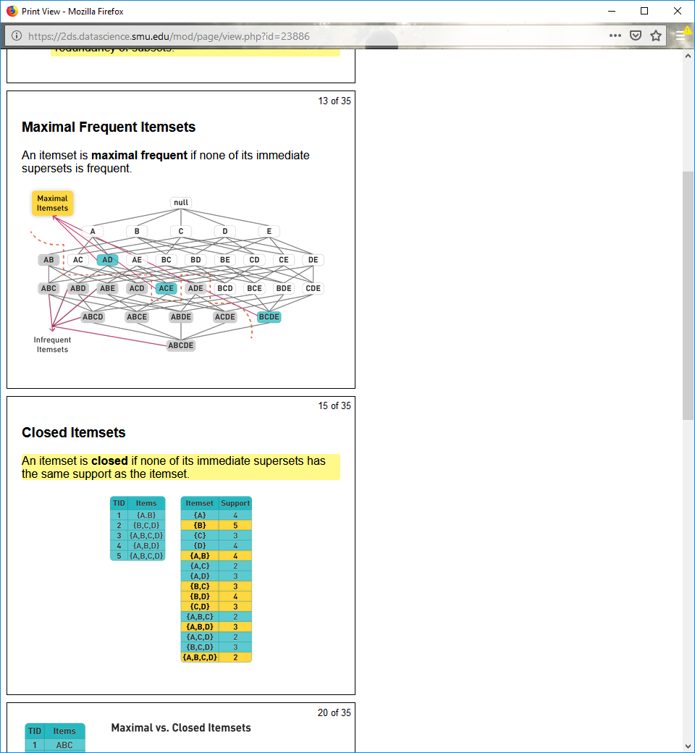

**Closed Itemsets**

An itemset is **closed** if none of its immediate supersets has the same support as the itemset.



**Maximal vs. Closed Itemsets**

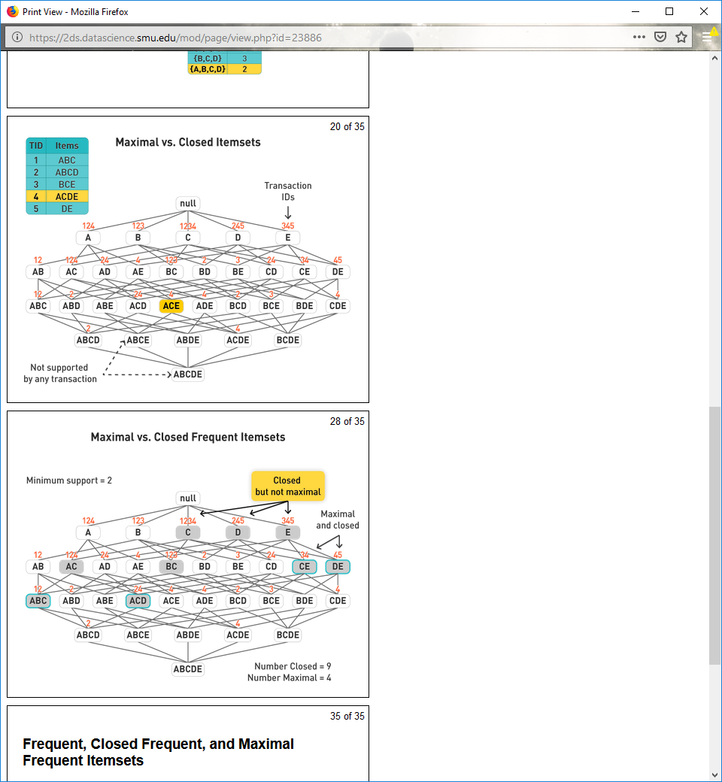

**Maximal vs. Closed Frequent Itemsets**



**Frequent, Closed Frequent, and Maximal Frequent Itemsets**

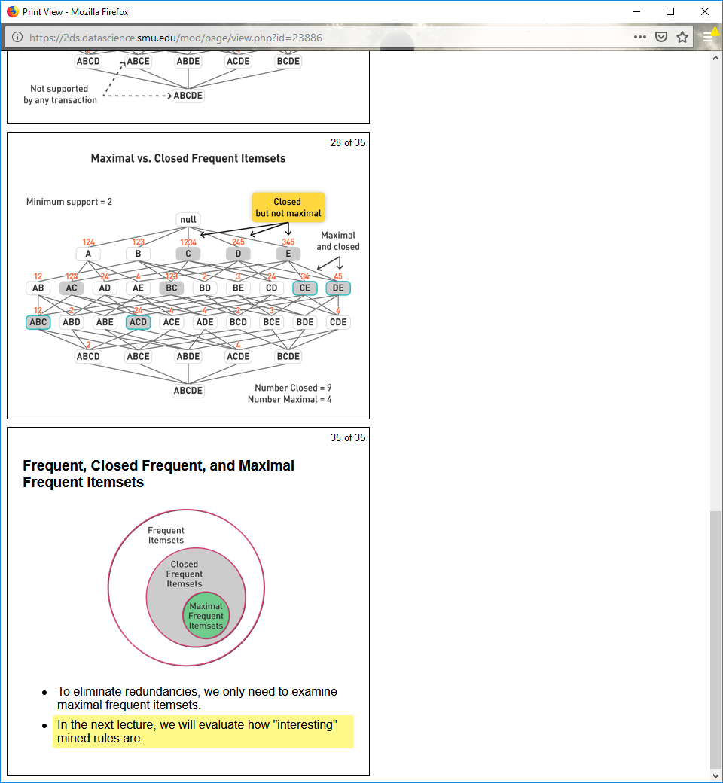

To eliminate redundancies, we only need to examine maximal frequent itemsets.

In the next lecture, we will evaluate how "interesting" mined rules are.

**12.8**

**Rule Evaluation**

Association rule algorithms tend to produce many rules that are **uninteresting** or **redundant**.

Example of redundant rules:

{A,B,C} → {D} and {A,B} → {D}

If both have same support and confidence

In the original formulation of association rules, support and confidence were the only measures used.

**Contingency Tables**

Contingency table for *X* → *Y*

|  |  |  |  |  |
| --- | --- | --- | --- | --- |
|  | Y | $$\overline{Y}$$ |  |  |
| X |  |  |  |  |
|  |  |  |  |  |
|  |  |  | |T| |  |

Given a rule *X* → *Y*, information needed to compute rule interestingness can be obtained from a contingency table.

$f_{11}$: support of X and Y

$f_{10}$: support of X and $\overline{Y}$

$f_{01}$: support of $\overline{X}$ and Y

$f_{00}$: support of $\overline{X}$ and $\overline{Y}$

Contingency tables can be used to define various measures.

**Drawback of Confidence**

Contingency table for Tea → Coffee

|  |  |  |  |  |
| --- | --- | --- | --- | --- |
|  | Coffee | $$\overline{Coffee}$$ |  |  |
| Tea | 15 | 5 | 20 |  |
| $$\overline{Tea}$$ | 75 | 5 | 80 |  |
|  | 90 | 10 | 100 |  |

Confidence = *P*(Coffee|Tea) = 0.75

But *P*(Coffee) = 0.9

Although confidence is high, the rule is misleading.

*P*(Coffee|) = 0.9375

Confidence, alone, does not show how good or interesting a rule might be.

**Statistical-Based Measures: Lift and Interest**

Lift and interest take statistical dependence into account.

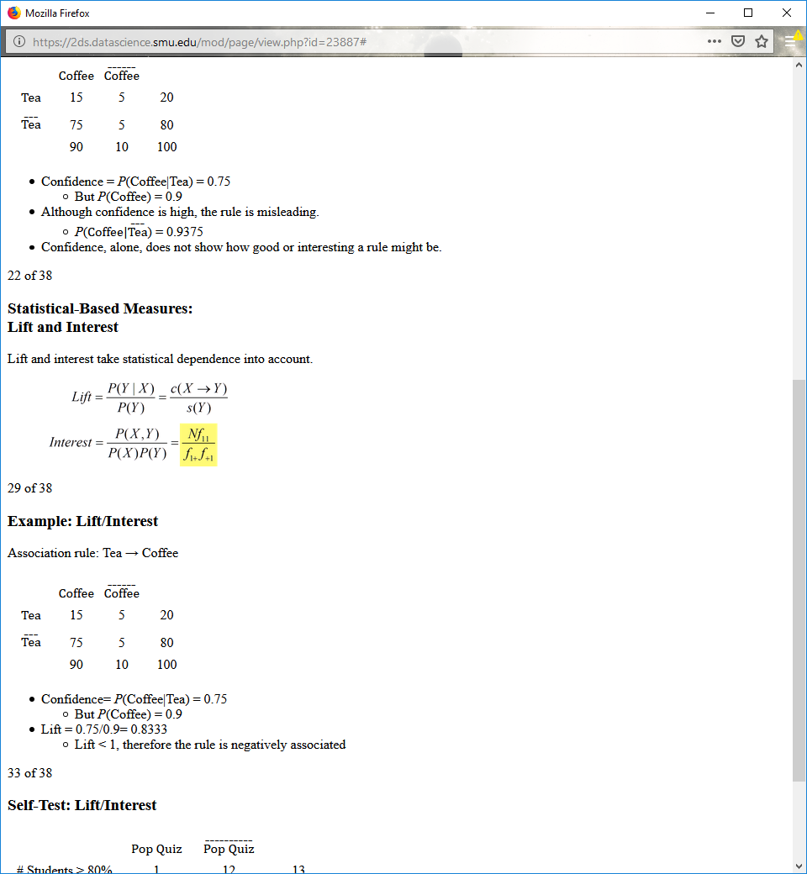

**Example: Lift/Interest**

Association rule: Tea → Coffee

|  |  |  |  |  |
| --- | --- | --- | --- | --- |
|  | Coffee | $$\overline{Coffee}$$ |  |  |
| Tea | 15 | 5 | 20 |  |
| $$\overline{Tea}$$ | 75 | 5 | 80 |  |
|  | 90 | 10 | 100 |  |

Confidence= *P*(Coffee|Tea) = 0.75

But *P*(Coffee) = 0.9

Lift = 0.75/0.9= 0.8333

Lift < 1, therefore the rule is negatively associated

**Self-Test: Lift/Interest**

|  |  |  |  |  |
| --- | --- | --- | --- | --- |
|  | Pop Quiz | $$\overline{Pop Quiz}$$ |  |  |
| # Students > 80% | 1 | 12 | 13 |  |
| # Students < 80% | 4 | 8 | 12 |  |
|  | 5 | 20 | 25 |  |

Calculate lift, interest, confidence, and support values for the association rule {# Students < 80%} → {Pop Quiz}.

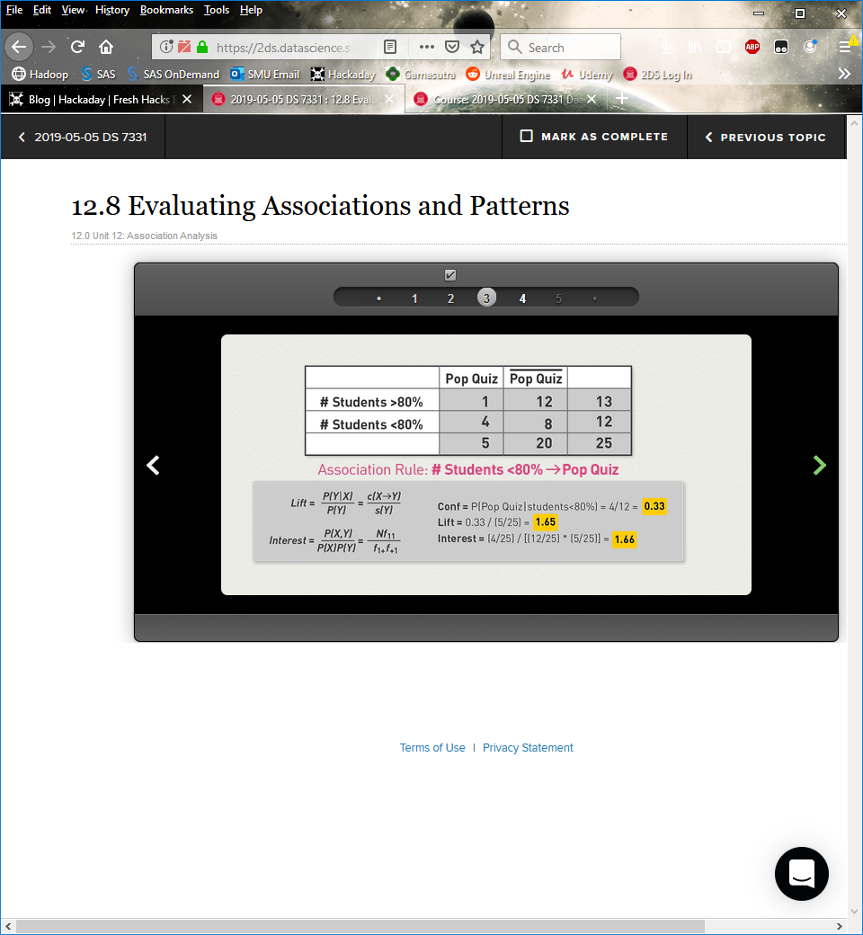

**Lift and Interest Self-Test: Review**

If lift < 1, rules are negatively associated.

If lift > 1, rules are positively associated.

**Drawback of Lift and Interest**

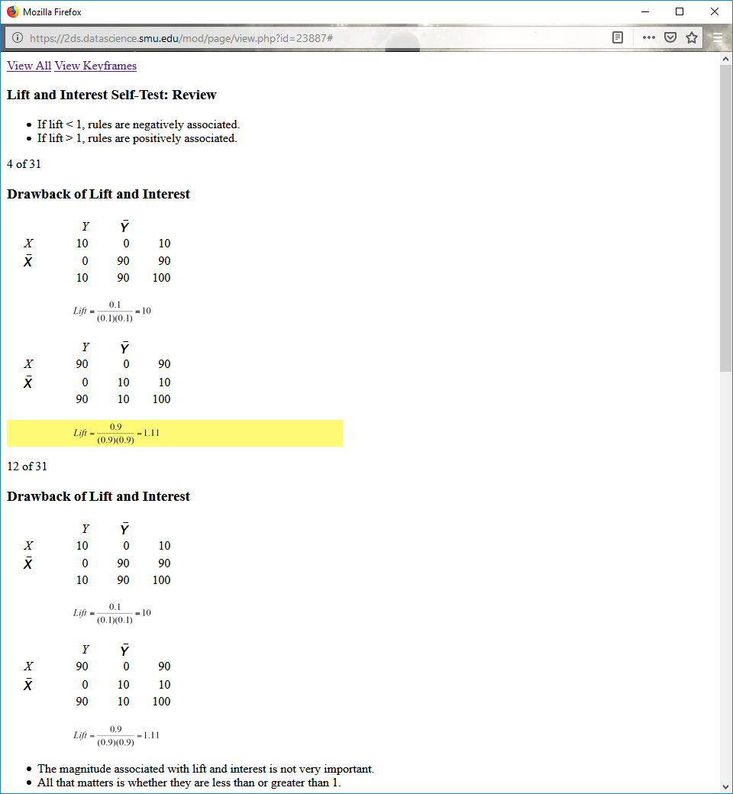

The magnitude associated with lift and interest is not very important.

All that matters is whether they are less than or greater than 1.

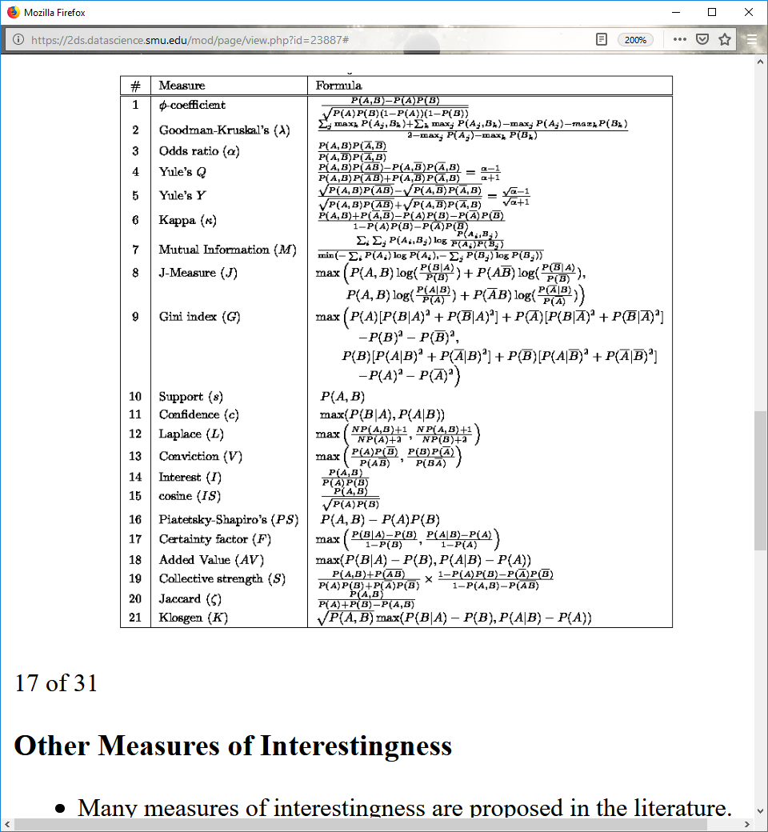

**Other Measures of Interestingness**

Many measures of interestingness are proposed in the literature.

Some are good for certain applications but not for others.

What criteria should we use to determine if a measure is good?

**Three Properties of a Good Measure**

1. If *A* and *B* are statistically independent, *M*(*A*,*B*) = 0.

2. *M*(*A*,*B*) increases monotonically with *P*(*A*,*B*) when *P*(*A*) and *P*(*B*) remain unchanged.

3. *M*(*A*,*B*) decreases monotonically with *P*(*A*) [or *P*(*B*)] when *P*(*A*,*B*) and *P*(*B*) [or *P*(*A*)] remain unchanged.

**Comparing Different Measures**

|  |  |  |  |  |  |
| --- | --- | --- | --- | --- | --- |
| Ten Example Contingency Tables | | | | |  |
| **Example** | **f11** | **f10** | **f01** | **f00** |  |
| **E1** | 8123 | 83 | 424 | 1370 |  |
| **E2** | 8330 | 2 | 622 | 1046 |  |
| **E3** | 9481 | 94 | 127 | 298 |  |
| **E4** | 3954 | 3080 | 5 | 2961 |  |
| **E5** | 2886 | 1363 | 1320 | 4431 |  |
| **E6** | 1500 | 2000 | 500 | 6000 |  |
| **E7** | 4000 | 2000 | 1000 | 3000 |  |
| **E8** | 4000 | 2000 | 2000 | 2000 |  |
| **E9** | 1720 | 7121 | 5 | 1154 |  |
| **E10** | 61 | 61 | 4 | 7452 |  |

|  |  |  |  |  |  |  |  |  |  |  |  |  |  |  |  |  |  |  |  |  |  |
| --- | --- | --- | --- | --- | --- | --- | --- | --- | --- | --- | --- | --- | --- | --- | --- | --- | --- | --- | --- | --- | --- |
| Rankings of Contingency Tables Using Various Measures: | | | | | | | | | | | | | | | | | | | | | |
| **#** | ***Φ*** | ***γ*** | ***α*** | ***Q*** | ***Y*** | ***κ*** | ***M*** | ***J*** | ***G*** | ***s*** | ***c*** | ***L*** | ***V*** | ***I*** | ***IS*** | ***PS*** | ***F*** | ***AV*** | ***S*** | ***ζ*** | ***K*** |
| **E1** | 1 | 1 | 3 | 3 | 3 | 1 | 2 | 2 | 1 | 3 | 5 | 5 | 4 | 6 | 2 | 2 | 4 | 6 | 1 | 2 | 5 |
| **E2** | 2 | 2 | 1 | 1 | 1 | 2 | 1 | 3 | 2 | 2 | 1 | 1 | 1 | 8 | 3 | 5 | 1 | 8 | 2 | 3 | 6 |
| **E3** | 3 | 3 | 4 | 4 | 4 | 3 | 3 | 8 | 7 | 1 | 4 | 4 | 6 | 10 | 1 | 8 | 6 | 10 | 3 | 1 | 10 |
| **E4** | 4 | 7 | 2 | 2 | 2 | 5 | 4 | 1 | 3 | 6 | 2 | 2 | 2 | 4 | 4 | 1 | 2 | 3 | 4 | 5 | 1 |
| **E5** | 5 | 4 | 8 | 8 | 8 | 4 | 7 | 5 | 4 | 7 | 9 | 9 | 9 | 3 | 6 | 3 | 9 | 4 | 5 | 6 | 3 |
| **E6** | 6 | 6 | 7 | 7 | 7 | 7 | 6 | 4 | 6 | 9 | 8 | 8 | 7 | 2 | 8 | 6 | 7 | 2 | 7 | 8 | 2 |
| **E7** | 7 | 5 | 9 | 9 | 9 | 6 | 8 | 6 | 5 | 4 | 7 | 7 | 8 | 5 | 5 | 4 | 8 | 5 | 6 | 4 | 4 |
| **E8** | 8 | 9 | 10 | 10 | 10 | 8 | 10 | 10 | 8 | 4 | 10 | 10 | 10 | 9 | 7 | 7 | 10 | 9 | 8 | 7 | 9 |
| **E9** | 9 | 9 | 5 | 5 | 5 | 9 | 9 | 7 | 9 | 8 | 3 | 3 | 3 | 7 | 9 | 9 | 3 | 7 | 9 | 9 | 8 |
| **E10** | 10 | 8 | 6 | 6 | 6 | 10 | 5 | 9 | 10 | 10 | 6 | 6 | 5 | 1 | 10 | 10 | 5 | 1 | 10 | 10 | 7 |

**Subjective Interestingness**

No objective measure of interestingness works all the time.

We need a **subjective measure of interestingness**.

A pattern is subjectively interestingly if:

It contradicts the expectation of a user

It is actionable

E.g., {High blood pressure, Frequent urination} → {Heart failure}

**Interestingness via Unexpectedness**

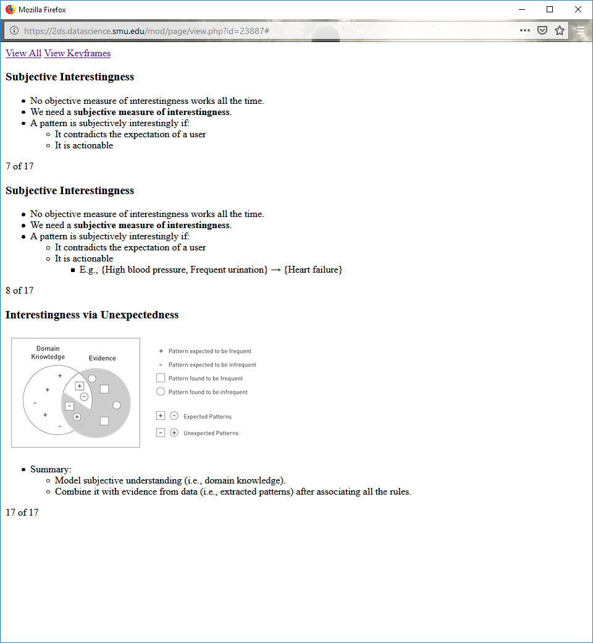

Summary:

Model subjective understanding (i.e., domain knowledge).

Combine it with evidence from data (i.e., extracted patterns) after associating all the rules.